A PROJECT REPORT

ON

**Online Shopping System**

Submitted in partial fulfilment of the requirement

For the award of the degree of

**BACHELOR OF COMPUTER APPLICATIONS**  
of

**Dayananda Sagar University**

(2022 -2025)

By

TEAM-9

|  |  |
| --- | --- |
| Blessto Gods Feareth D | ENG22CA0017 |
| Harshith S | ENG22CA0024 |
| Kishore A | ENG22CA0031 |
| Bala Vinay M | ENG22CA0057 |

Under the guidance of

**Dr. P. Baby Maruthi, Assistant Professor**

**DEPARTMENT OF COMPUTER APPLICATIONS**

**DAYANANDA SAGAR UNIVERSITY**

**BENGALURU-560014**

**DECLARATION**

We hereby declare that the Project Report titled “**Online Shopping System”** submitted to **Dayananda Sagar University, Bengaluru** in partial fulfilment of the requirements for the award of the Degree of **Bachelor of Computer Applications** is a report of work done by us under the supervision of **Dr. P. Baby Maruthi.** We also declare that this report or any part of it has not been submitted to any other University/Institute for the award of any degree.

By

Blessto Gods Feareth D (ENG22CA0017):

Harshith S (ENG22CA0024):

Kishore A (ENG22CA0031):

Bala Vinay M (ENG22CA0057):

**DEPARTMENT OF COMPUTER APPLICATIONS**

DAYANANDA SAGAR UNIVERSITY

KUDLU GATE, HOSUR ROAD, BENGALURU - 560068



**BONAFIDE CERTIFICATE**

This is to certify that the project titled **“Online Shopping System”** is a bonafide record of the work done by

* **Gods Feareth D** (ENG22CA0017),
* **Harshith S** (ENG22CA0024),
* **Kishore A** (ENG22CA0031),
* **Bala Vinay M** (ENG22CA0057).

In partial fulfilment of the requirements for the award of the degree of **Bachelor of Computer Applications** in DAYANANDA SAGAR UNIVERSITY, BENGALURU during the academic year 2022-23.

|  |  |
| --- | --- |
| Guide  **Dr. P. Baby Maruthi**  Assistant Professor,  Dept. of Computer Applications,  Dayananda Sagar University | Chairman  **Dr. Vasanti Kumari P**  Chairman,  Dept of Computer Applications,  Dayananda Sagar University |

Project Viva Held on: _________________________

|  |  |
| --- | --- |
| **Internal Examiner** | **External Examiner** |

**ACKNOWLEDGEMENT**

We wish to express our salutation to the beloved and highly esteemed institution DAYANANDA SAGAR UNIVERSITY.

We would like to thank **Dr. Uday Kumar Reddy K R**, **Dean, School of Engineering**, Dayananda Sagar University, Bengaluru, for his valuable suggestions and expert advice.

We would also like to thank **Dr. Vasanthi Kumari P, Chairman, Department of Computer Applications,** Dayananda Sagar University for her valuable guidance and constant support through-out the project.

We are grateful to our guide and would like to express special thanks to **Dr. P. Baby Maruthi, Assistant professor,** Department of Computer Applications, DSU for her constant support, necessary advices and valuable guidance that helped us in completing the project/report work successfully.

We would like to thank all the teaching and non-teaching staff of Department of Computer Applications, DSU for their help. We would like to extend the thanks to our parents and friends who have always supported us in every path of the report work.

We perceive this opportunity as a milestone in our career development. We will strive to use the acquired skills and knowledge in the best possible way and we will continue to work on our improvement in order to achieve the desired career objectives. We hope to continue the cooperation with all of you in the future.

**Signature of Student:**

Blessto Gods Feareth D (ENG22CA0017):

Harshith S (ENG22CA0024):

Kishore A (ENG22CA0031):

Bala Vinay M (ENG22CA0057):

|  |  |
| --- | --- |
|  | **Sign of Internal Guide** |

**Abstract**

The online shopping system has revolutionized the retail industry, providing consumers with a convenient and accessible way to shop. Through e-commerce websites and platforms, buyers and sellers can connect in a virtual marketplace, offering a range of benefits. Consumers can browse a vast array of products and make informed purchasing decisions with just a few clicks. The 24/7 availability of online shopping allows shoppers to shop at their convenience, eliminating the constraints of traditional store hours. Additionally, the global nature of online shopping enables access to products from around the world, expanding consumer choices. The online shopping system also enhances customer experiences through personalized recommendations and prompt customer support service. Overall, the online shopping system has transformed the way people shop, providing convenience, choice, and accessibility to consumers worldwide.

**Table of Contents**

**CHAPTER 1** 1

**INTRODUCTION** 1

**OBJECTIVES:** 1

**SCOPE:** 1

**ADVANTAGES:** 2

**TOOLS AND TECHNOLOGIES USED:** 2

**CHAPTER 2** 3

**SYSTEM ANALYSIS** 3

**Preliminary analysis & Information gathering:** 3

**Input/outputs** 3

**Feasibility Study:** 4

**System Requirements Specification:** 4

**Software Engineering Model:** 5

**Project Scheduling:** 5

**CHAPTER 3** 6

**SYSTEM DESIGN** 6

**Project Planning:** 6

**MODULES** 7

**Screenshots:** 8

**CHAPTER 4** 27

**TESTING:** 27

**CHAPTER 5** 27

**IMPLEMENTATION:** 27

**Source Code:** 28

**CHAPTER 6** 63

**REFERENCES (BIBLIOGRAPHY)** 63

**CONCLUSION & FUTURE RECOMMENDATIONS** 63

# **CHAPTER 1**

## **INTRODUCTION**

Online Shopping System has revolutionized the retail landscape, offering consumers a convenient and accessible ways to browse, select and services. Through e-commerce websites and platforms, the online shopping system connects buyers and sellers in virtual marketplace. This system provides numerous benefits, including 24/7 availability, eliminating the constraints of physical store hours. Consumers gain access to wide range of products from around the world, expanding their choices and options.

With its convenience and flexibility, the online shopping system has become an integral part of modern consumer behaviour.

**OBJECTIVES:**

* **Convenience:** The primary objective of the online shopping system is to provide convenience to consumers by allowing them to browse from the comfort of their homes.
* **Accessibility:** Online shopping aims provide accessibility to a wide range of products and services, which the barriers when the shopper says “NO STOCK”.
* **Global Reach**: The online shopping system facilitates global connectivity between buyers and sellers.
* **Personalization**: Online shopping system aim to personalize the shopping experience for consumers.
* **Customer support**: Providing prompt and effective customer support is an important objective of the online shopping system.

**SCOPE:**

* **Social Commerce**: The scope of online shopping extends to social media platforms, where consumers can discover the products directly.
* **Digital Marketplaces**: Online shopping includes the scope of digital marketplaces, where multiple sellers can showcase and sell their products.
* There may be B2B or B2C transactions happening cross the global.
* With emerging technologies products can be viewed in 3D points also.
* Diverse Product Range: Online shopping offers a wide scope of products and services.

## **ADVANTAGES:**

* Saves time and efforts.
* The convenience of shopping at home.
* Wide variety of products are available.
* Get detailed information about the product.
* Availability which is open 24/7.

# **TOOLS AND TECHNOLOGIES USED:**

* HTML: The basic structure and content of the page are written in HTML (Hypertext Markup language).
* CSS: Cascading Style Sheets (CSS) are used to define the visual styles of the page, including fonts, colours, layout, and spacing. The CSS files are linked to HTML files using <link> tag.
* VS Code: Virtual Studio Code (VS code) are used as IDE to edit the HTML and CSS files.

**CHAPTER 2**

**SYSTEM ANALYSIS**

## **Preliminary analysis & Information gathering:**

The development of an online shopping system involves a preliminary analysis and information gathering phase to ensure its successful implementation. This phase aims to gather requirements, analyse business processes, and define the scope of the system. The initial step is to identify key customers, sellers, and administrators, and gather their specific needs and expectations. This includes understanding the desired features, user interface requirements.

Additionally, it is essential to conduct market research to gain insights into the current online shopping landscape, identify competitors, and analyse industry trends.

The preliminary analysis and information gathering phase provides a foundation for the subsequent stages of system development, including design, implementation, and testing. By thoroughly understanding the requirements and gathering relevant information, the online shopping system can be tailored to meet the needs of the target audience and provide an optimal user experience.

**Input/outputs**

* **Input:**
* **User Information**: Customers provide their personal details, such as name, address, phone no.
* **Product Information**: Product details, including name, description, price and images are entered into system by the admin.
* **Order Updates**: System receives inputs from external sources, such as shipping providers, management system.
* Browse through different categories.
* **Output:**
* **Product Listings**: The system displays a list of products based on user search or category selections.
* **User Account Management**: The system provides options for user to manage their accounts, update personal information.
* **Order tracking**: Customers can track the status of their orders.

## **Feasibility Study:**

The feasibility study is an important step in any project to determine whether it is feasible or not. Here is a feasibility study for the “Online Shopping” project:

1. **Technical Feasibility:**

The Technical feasibility of an online shopping system refers to the evaluation of whether the necessary technology resources, and expertise are available to develop and operate the system. It involves assessing factors such as website development, hosting and others. Technical feasibility analysis ensures that the online shopping system can be effectively implemented.

1. **Operational feasibility:**

The operational feasibility of an online shopping system refers to assessing whether the system can be effectively integrated into existing business operations and processes. It considers factors such as the availability of resources, training needs, impact on workflows. Operational feasibility analysis helps determine if the online shopping system can be successfully implemented and sustained in the organization’s operations.

1. **Schedule Feasibility:**

Schedule feasibility of an online shopping system refers to evaluating whether the project can be completed within the desired timeframe. It considers factors such as available resources, complexity of the system and needed risks. Schedule feasibility analysis ensures that the project can be realistically executed and delivered in planned time.

## **System Requirements Specification:**

* **Software Requirements:**
* Visual Studio code(recommend 1.75)
* Extensions for HTML and CSS
* Chrome (for displaying the Output) Web browser
* Operating System: Windows 10 or 11 (RECOMMENDED), MAC OS
* **Hardware Requirements:**
* Processor: x64 bit or above
* RAM 4 GB or above
* Hard Disc: Up to 16GB of free space.

**Software Engineering Model:**

The software engineering model used in this project is not explicitly stated in the code provided. However, based on the nature of the project and code required, it appears to follow an incremental development approach. This is because the code is divided into multiple function that are designed to be tested and implemented incrementally.

## **Project Scheduling:**

1. Break down the project into smaller tasks: The first step would be to identify all the tasks required to complete the project. These tasks should be broken down into smaller sub-tasks so that they are easier to manage.
2. Determine task dependencies: Next, you would need to determine which tasks are dependent on others. For example, you may need to complete one task before you can start another. It's important to identify these dependencies, as they can have a significant impact on the project timeline.
3. Estimate task duration: Once you have identified all the tasks and their dependencies, you can estimate how long each task will take to complete. This will help you create a timeline for the project.
4. Allocate resources: You need to determine what resources will be needed to complete each task. This could include people, equipment, or software. You should also identify any constraints that could impact resource allocation, such as budget or availability.
5. Create a project timeline: Based on the estimated task duration and resource allocation, you can create a project timeline. This will help you determine when each task needs to be started and completed in order to meet the project deadline.
6. Monitor progress: Once the project is underway, it's important to monitor progress regularly. This will help you identify any errors or delays, and make adjustments to the project schedule as needed.
7. Adjust the schedule as needed: Finally, you may need to make adjustments to the project schedule based on changes in scope, resource availability, or other factors. It's important to be flexible and adaptable throughout the project to ensure its success.

# **CHAPTER 3**

## **SYSTEM DESIGN**

The system design for an online shopping system involves various components and consideration. It typically includes a user interface for customers to browse and select products.

Additionally, the design incorporates features like personalized recommendations, and customer support. Scalability and reliable shopping experience and a robust product catalog management system is necessary to organize and display the available products.

Overall, the system design aims to provide a user-friendly, efficient, and seamless integration with external services. It should prioritize an exceptional user experience and scalability to meet the demands of modern online shoppers.

## **Project Planning:**

Project planning is a crucial process that helps ensure that the project is completed on time, within budget, and meets the requirements. Here are some key steps that can be followed for project planning:

* Define the project scope: This involves identifying the goals and objectives of the project, as well as the deliverables and timelines.
* Create a work breakdown structure (WBS): The WBS is a hierarchical breakdown of the project into smaller, more manageable tasks. It helps to identify the resources needed for each task and provides a roadmap for the project.
* Identify the project team: Determine the roles and responsibilities of the project team members, and establish communication channels and workflows.
* Define the project schedule: This involves creating a timeline for the project, including deadlines and milestones.
* Risk assessment and mitigation: Identify potential risks and develop strategies to mitigate them.
* Quality assurance: Establish quality standards and procedures to ensure that the project meets the requirements.
* Monitor and control: Regularly review the project progress and make adjustments as necessary to keep the project on track.

## **MODULES**

1. Home page
2. Beauty
3. Fashion
4. Electronics
5. Customers support
6. Signup page

**Explanation of above modules:**

1. **Home page:**

The home page of this project is designed to showcase the website’s main content, which are the products present in the whole webpages. The page has a navigation bar that includes links to the home page, mobiles, Electronics, Beauty, Signup page, Fashion and Customer care. When clicked on Beauty it will be navigated to beauty page.

1. **Beauty**:

This page contains all the beauty products used by men and women. User can scroll down see the products.

1. **Fashion**:

This page consists of 3 sections Men, Women and kids. When clicked on men it will be taken to men page which contains 7 sub section like shirts, t-shirts, jeans, shoes, flipflops, accessories and traditional dresses. In women section it has 6 sub sections like sarees, kurtas, handbags, shoes and accessories. In kids section it contains clothes and many more.

1. **Electronics**:

This page contains 8 sections called desktop, speaker, phone, tablets, headset, laptop, smartwatch and air pods.

1. **Customer care**:

This page contains support with the ordered products like helping you with tracking the order or order with wrong address and others.

1. **Signup page**:

In this page you can login to your account and search, if you’re a new customer you can just create a account.

**Screenshots:**

* **Homepage**

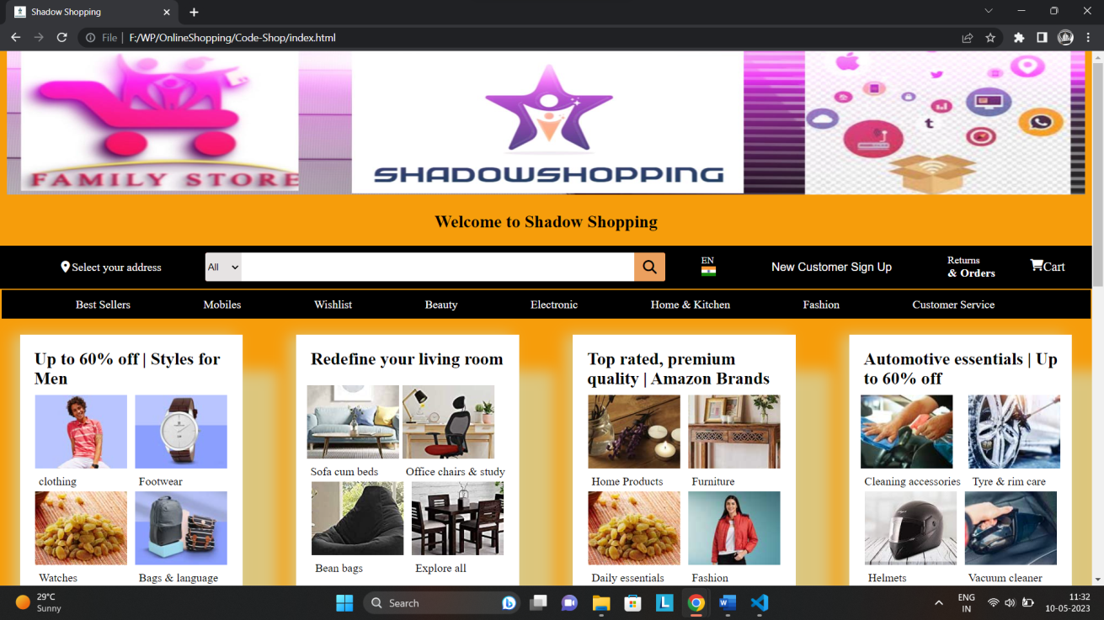

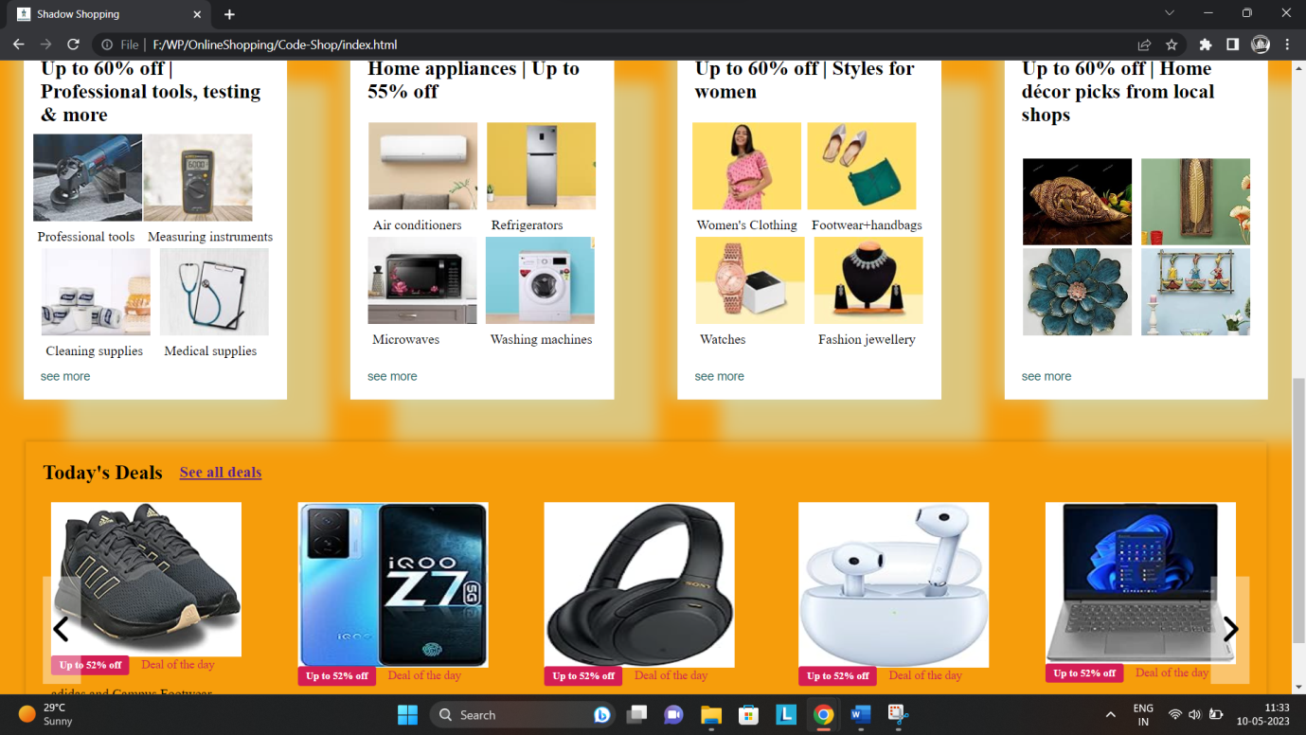

* **Mobiles:**

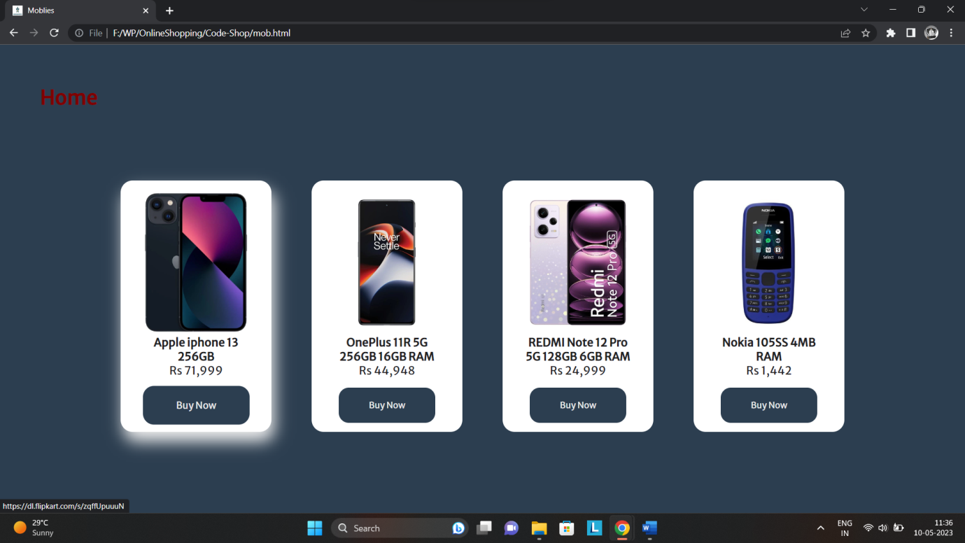

* **Beauty:**

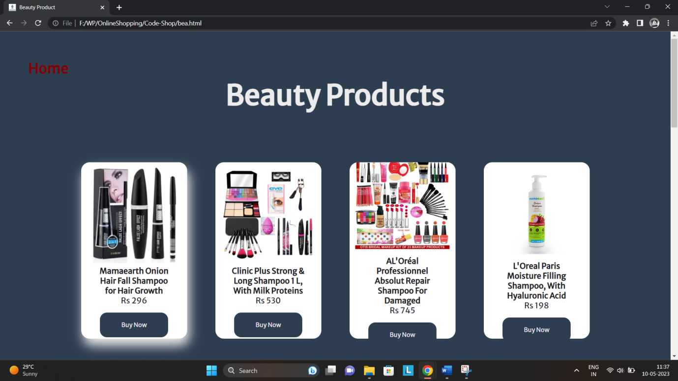

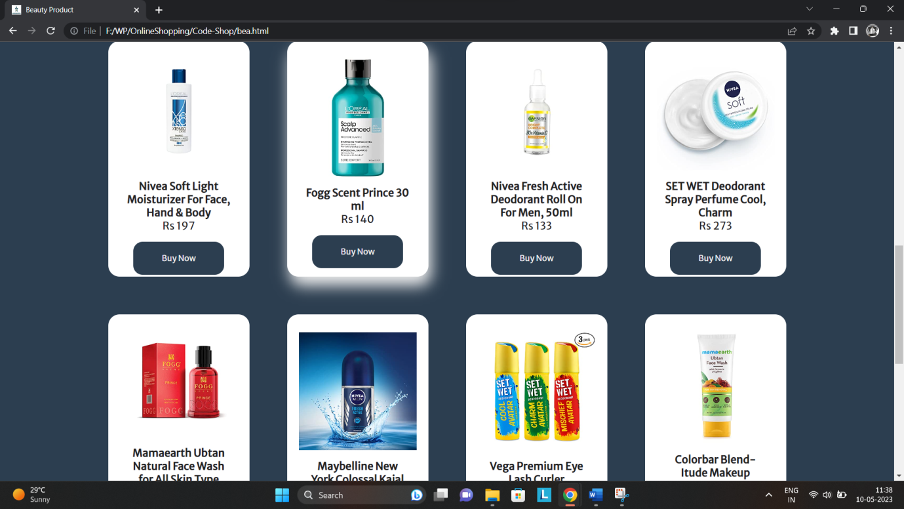

* **Electronics:**

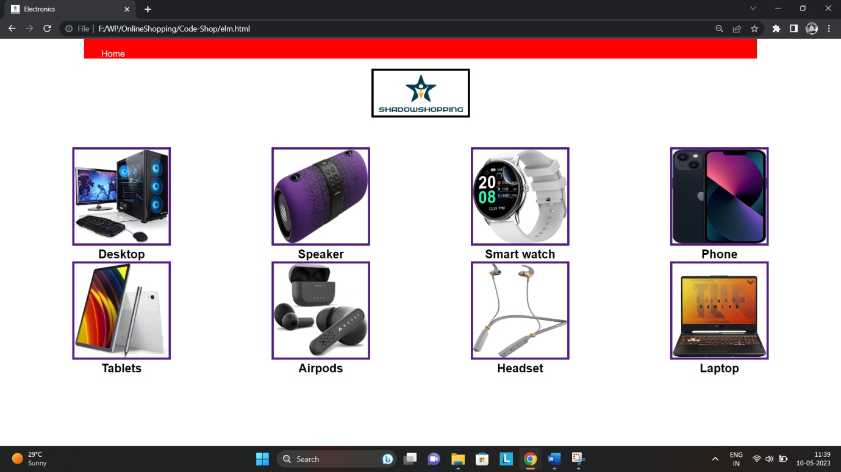

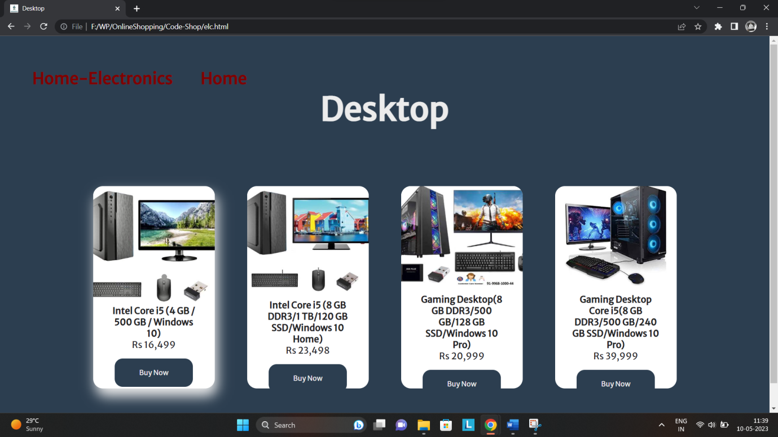

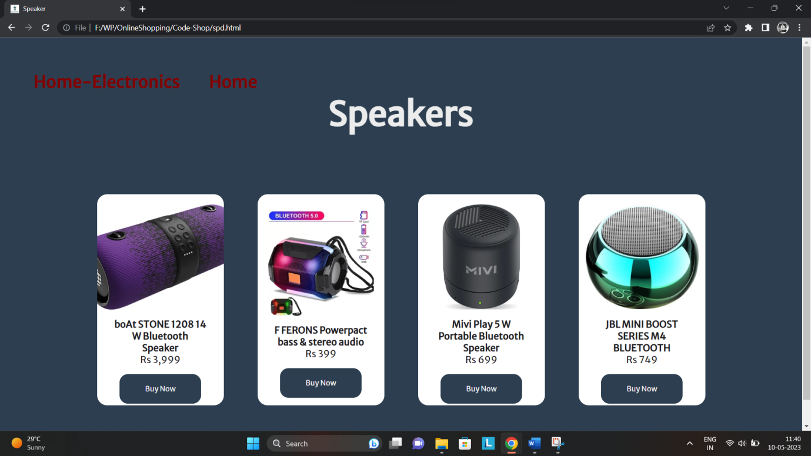

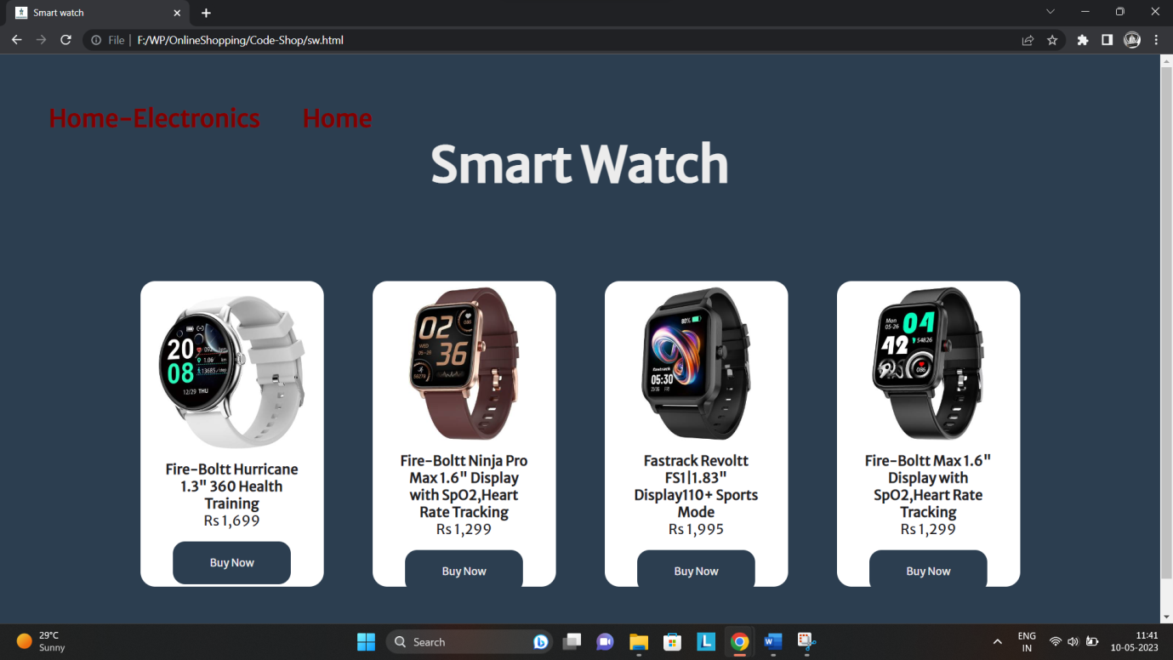

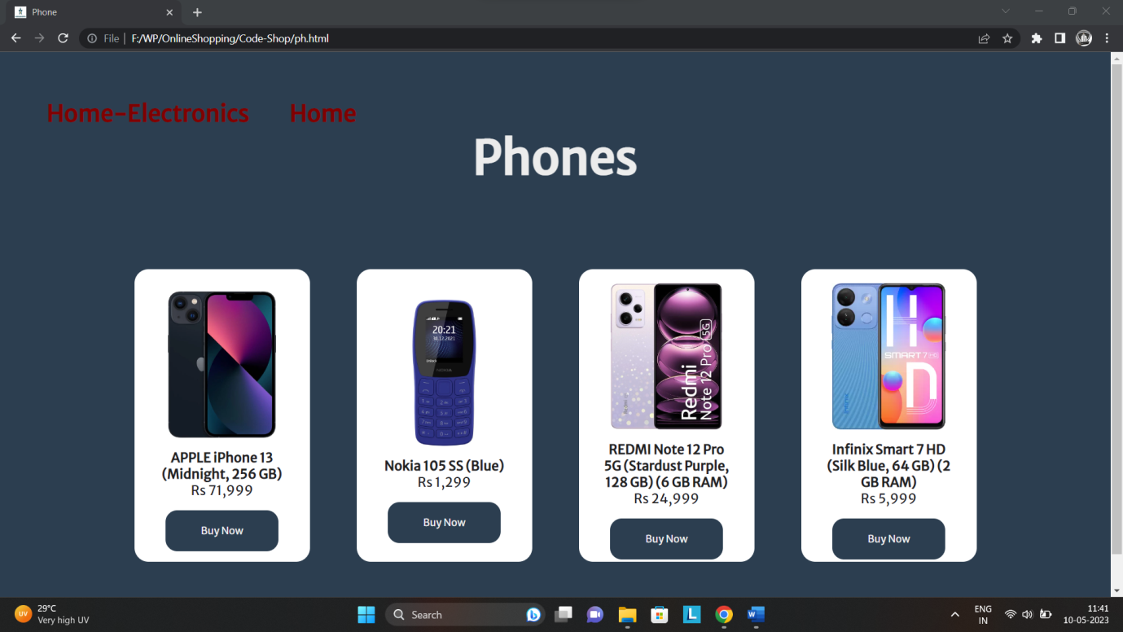

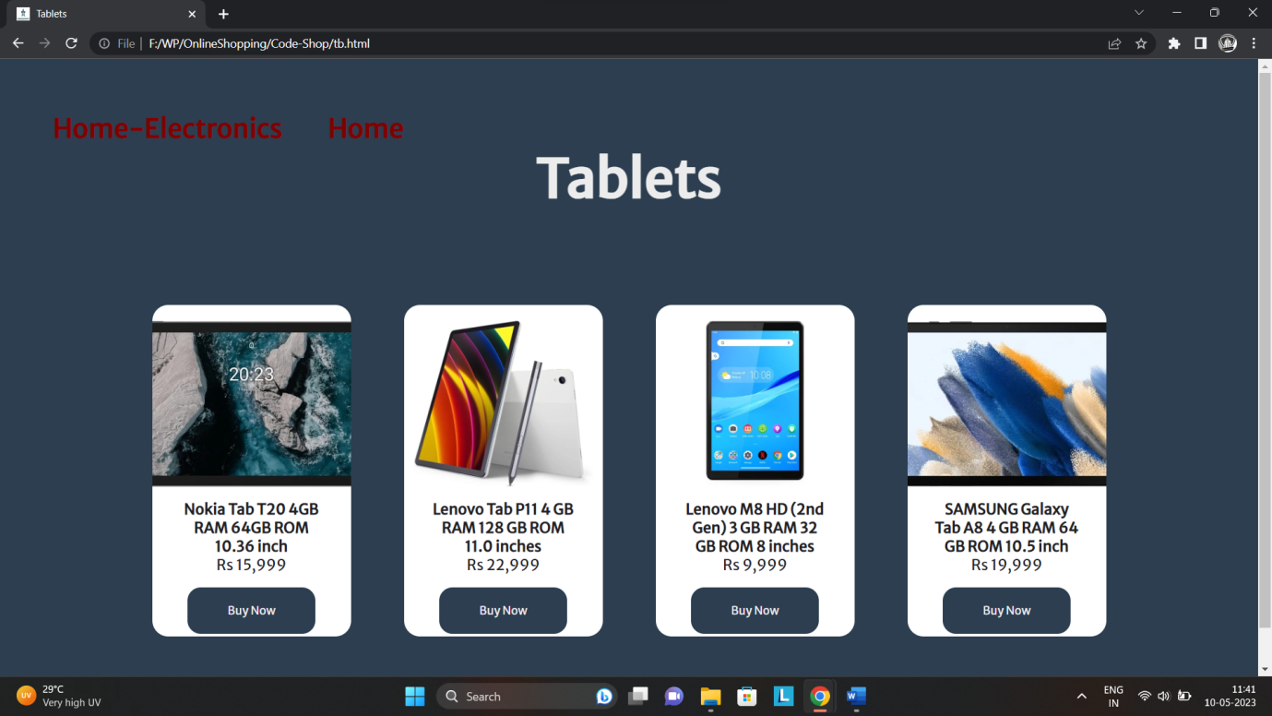

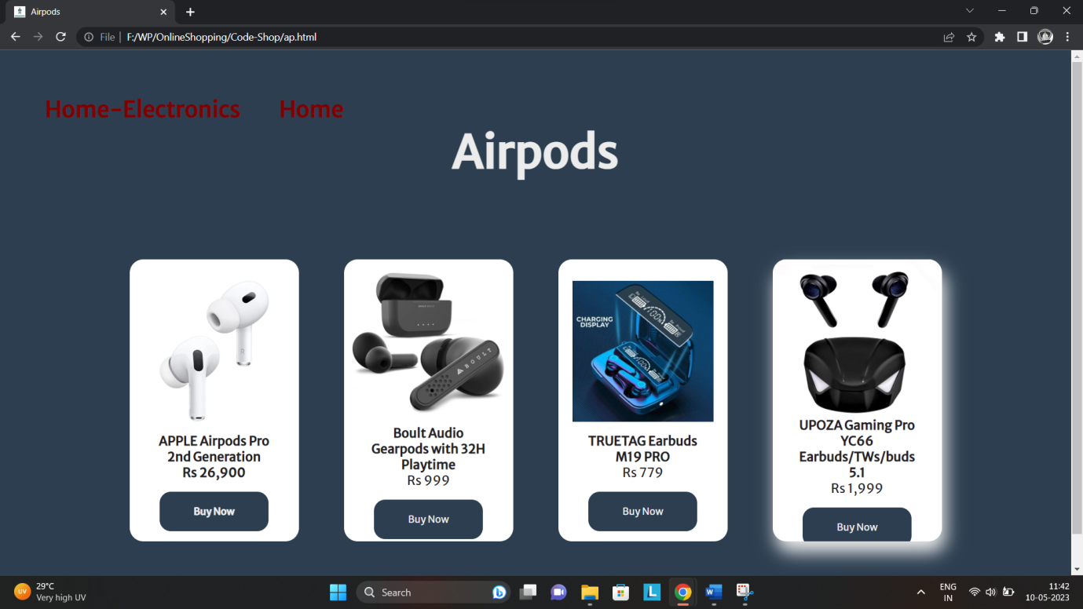

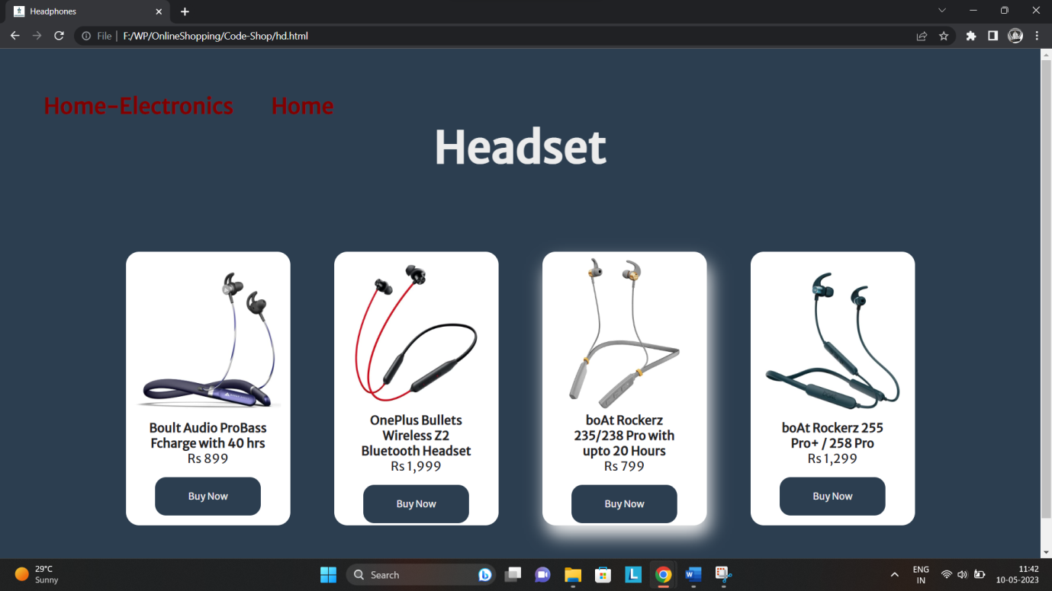

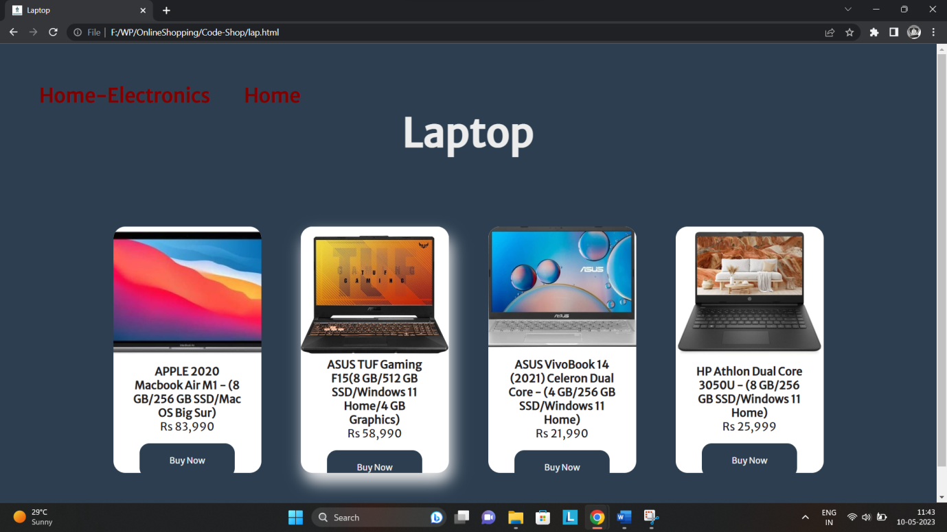

* **Fashion:**

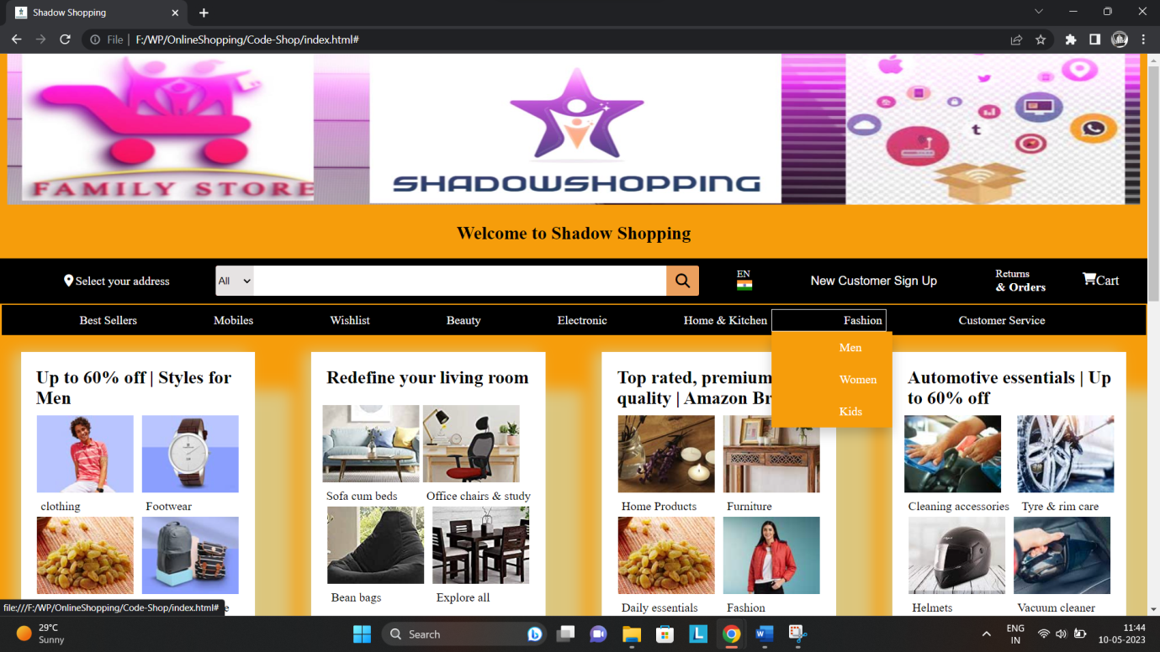

* **Fashion -> Men**

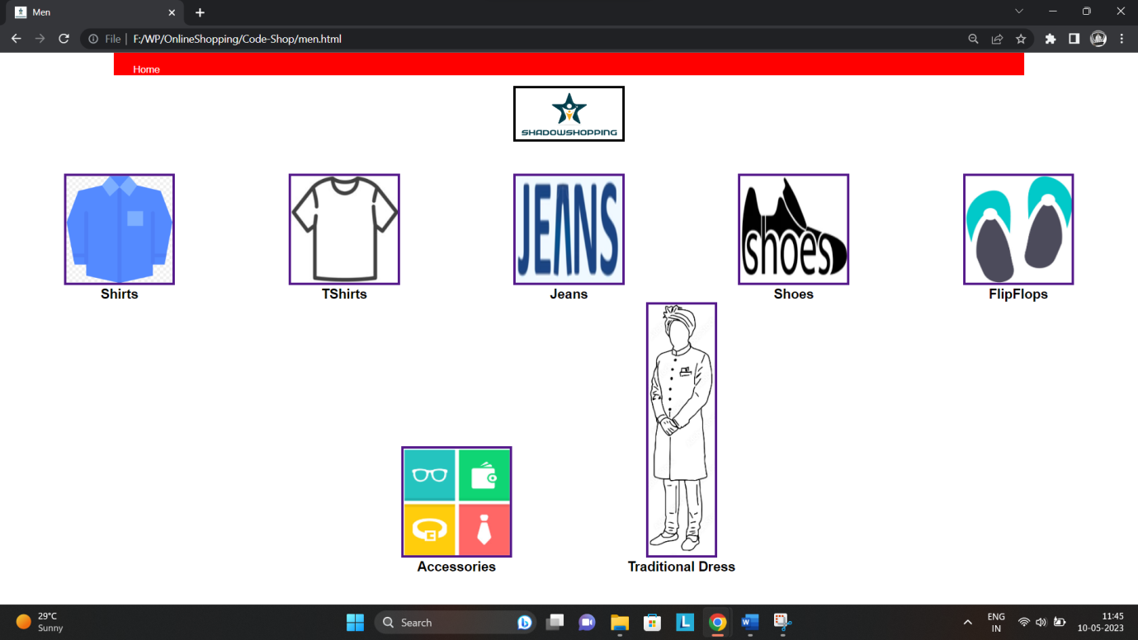

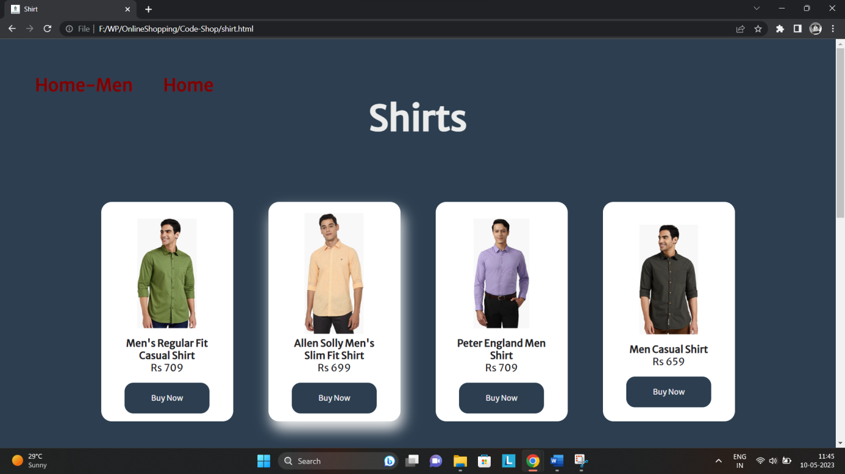

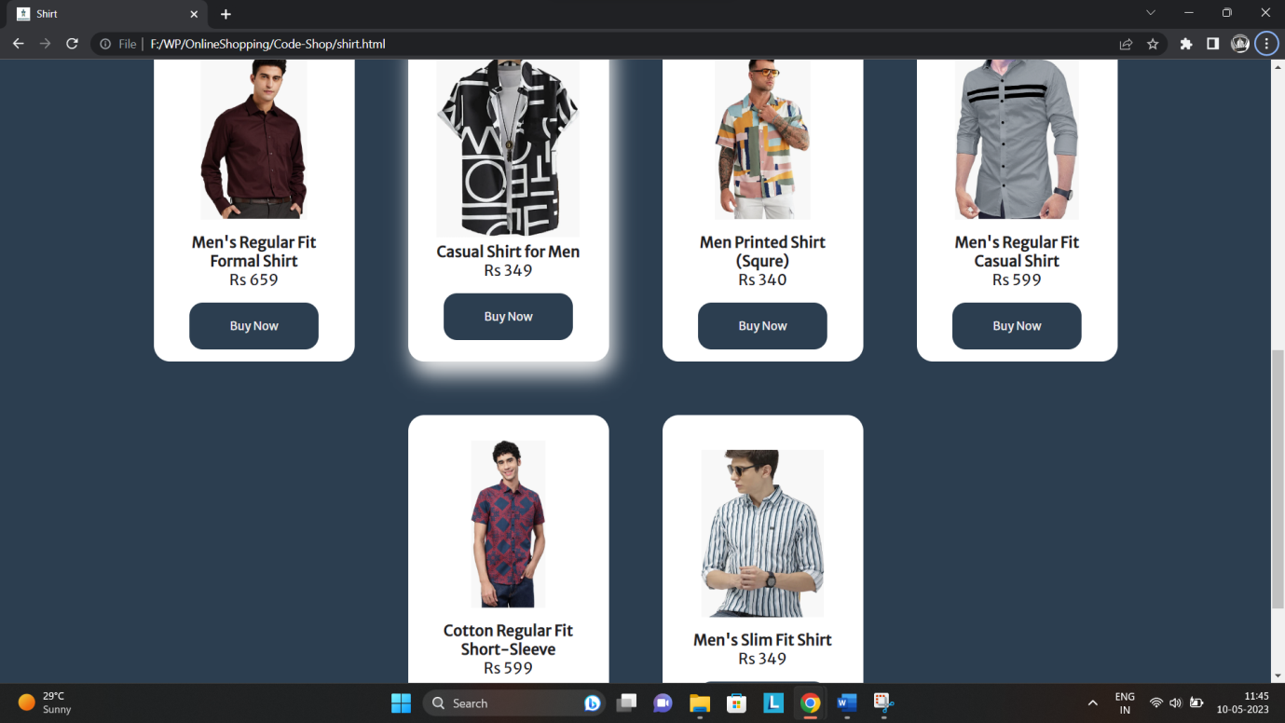

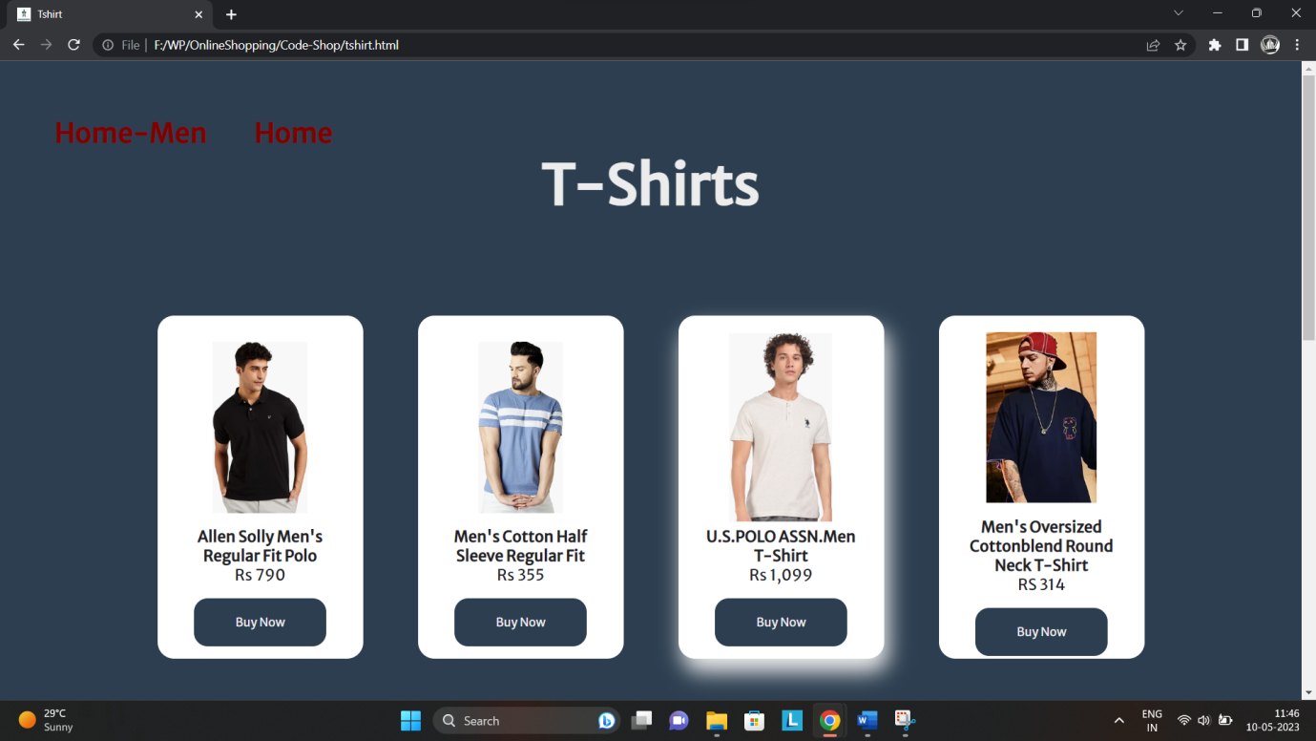

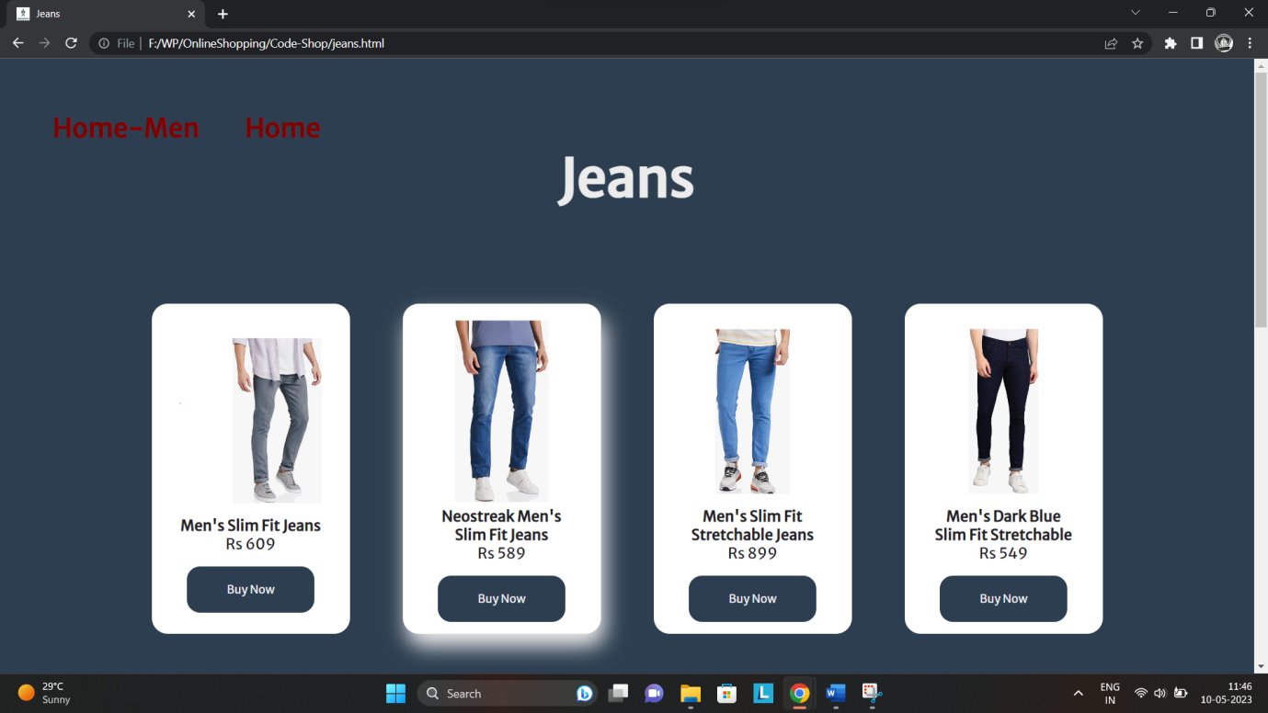

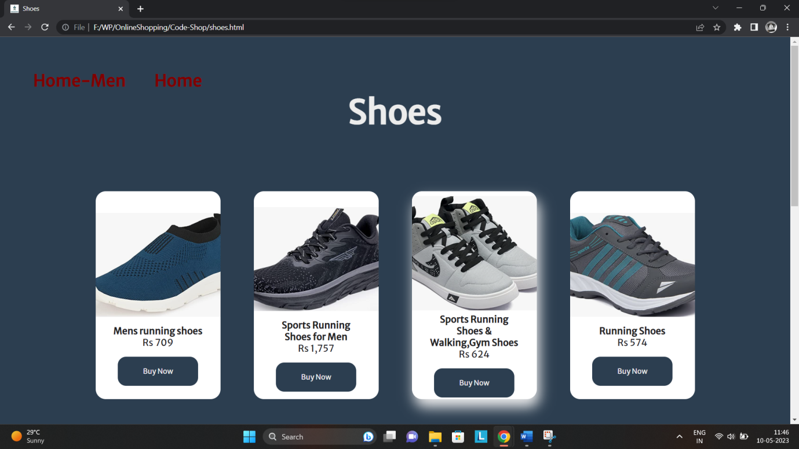

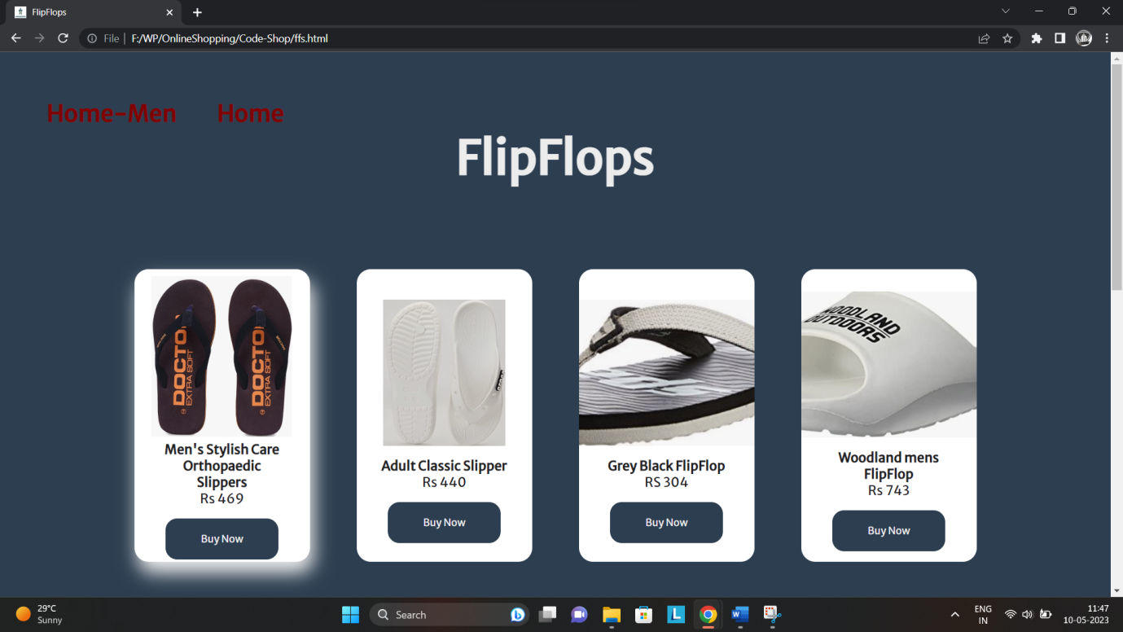

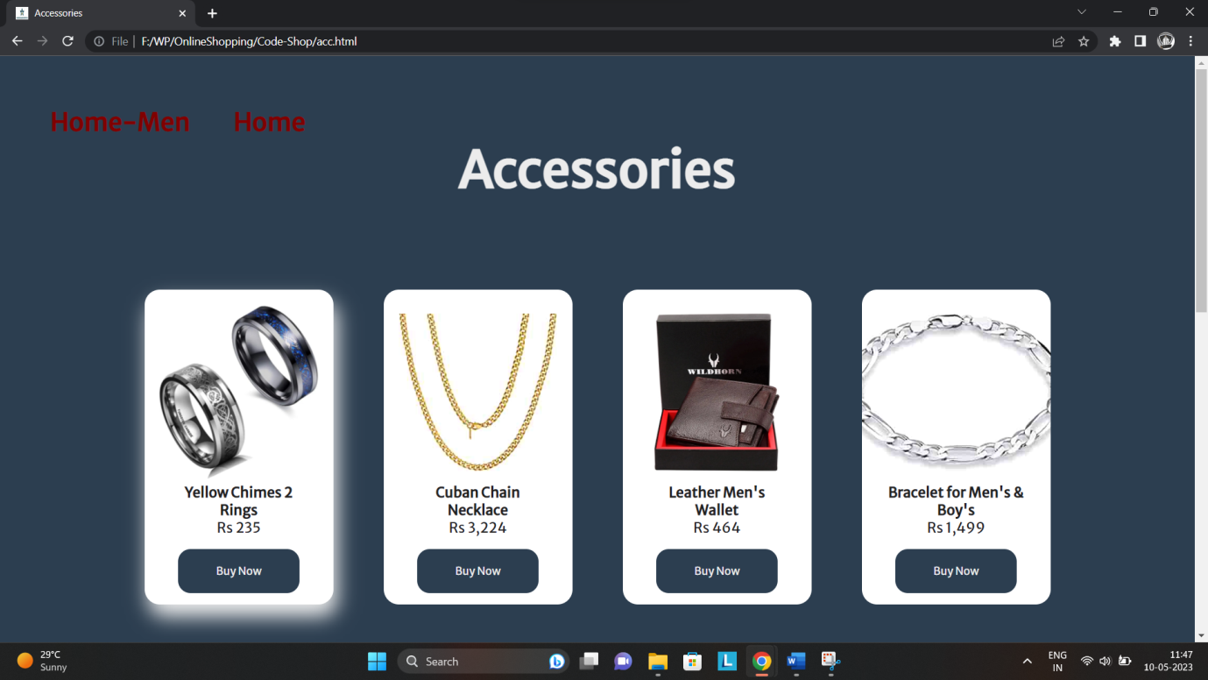

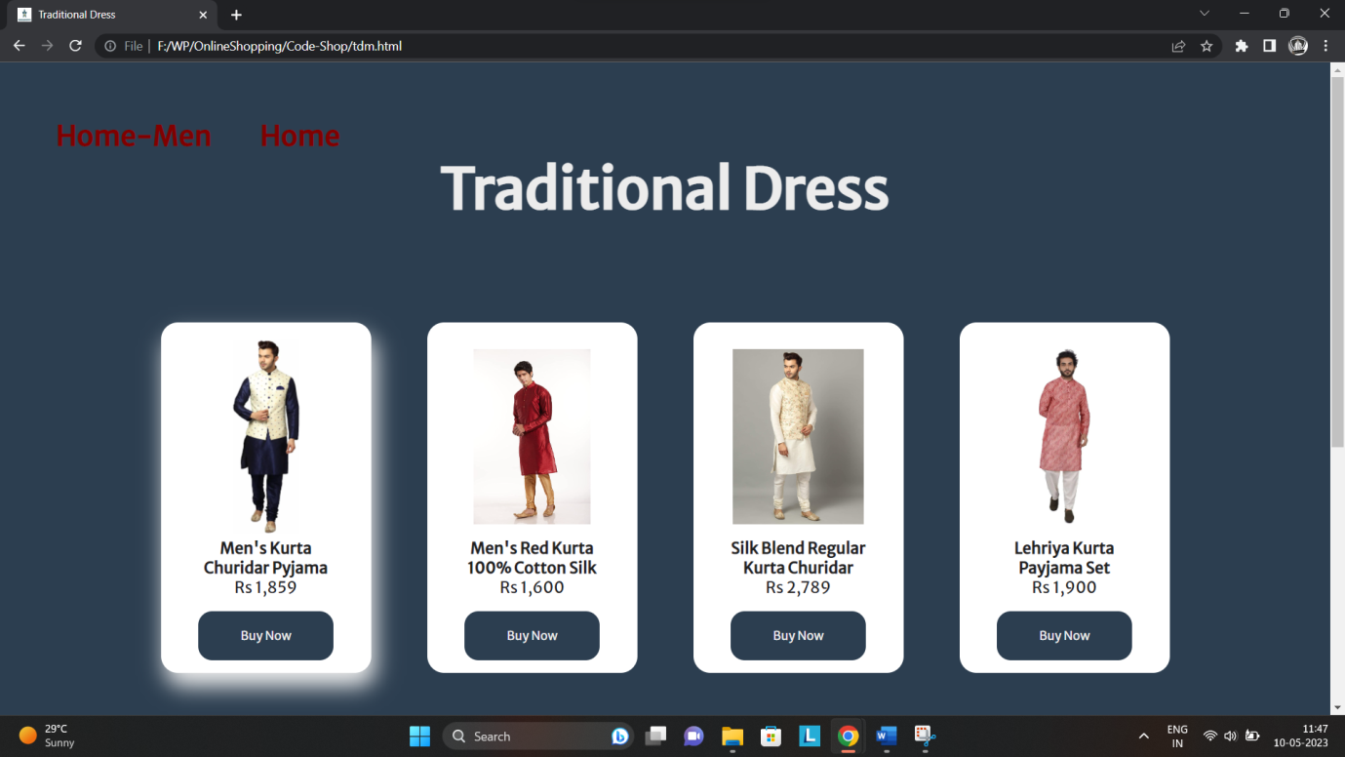

* **Fashion -> Women**

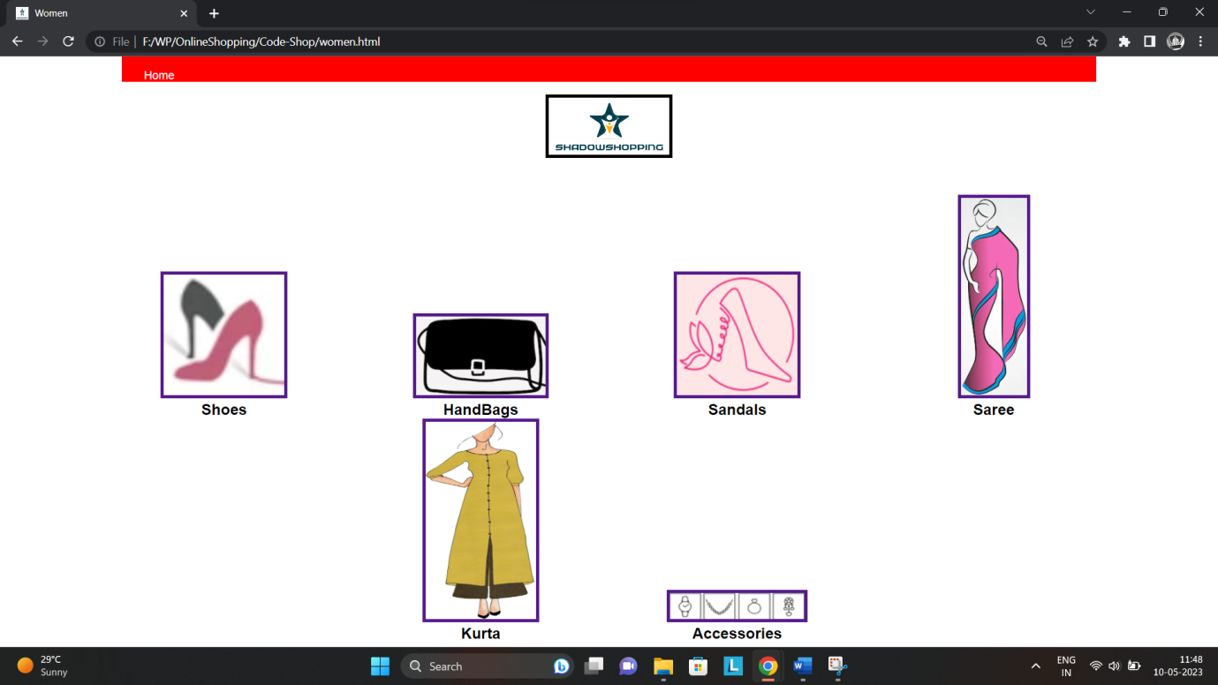

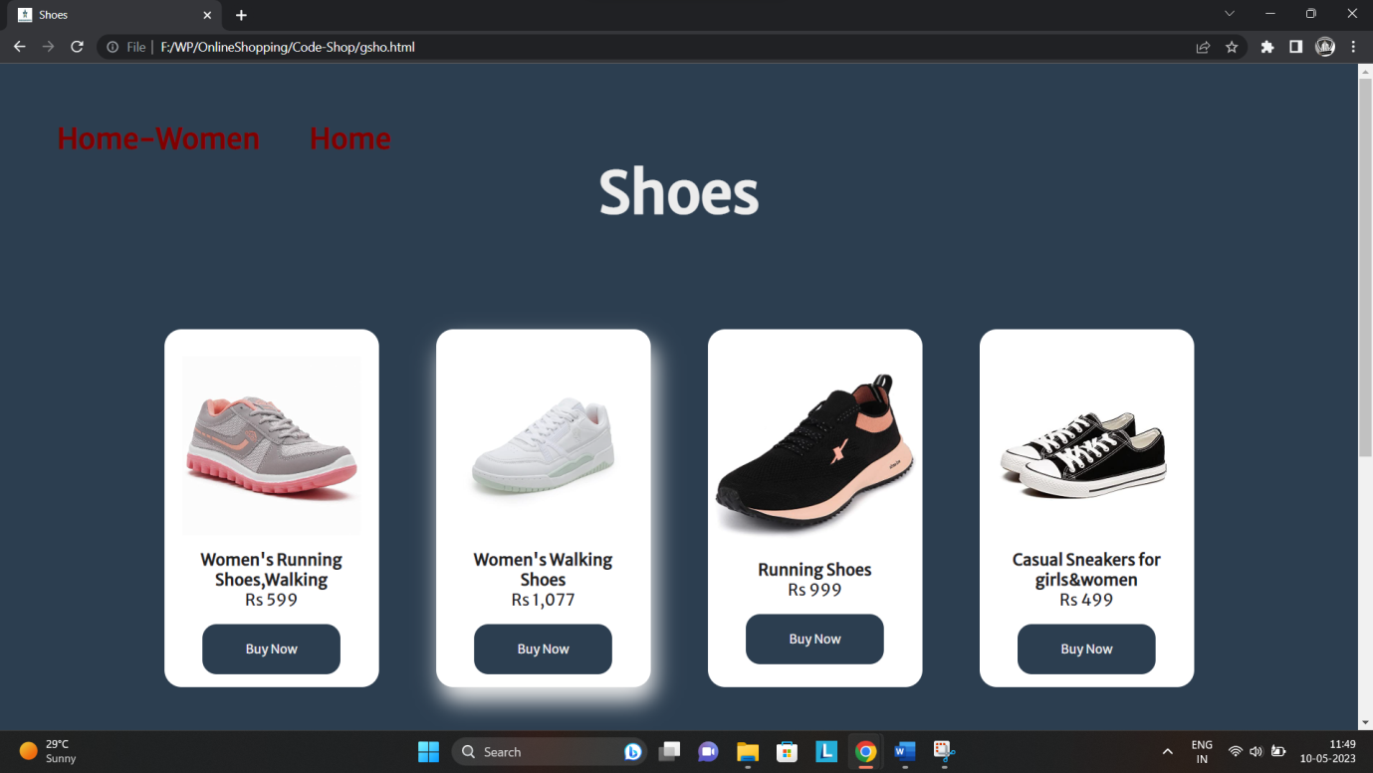

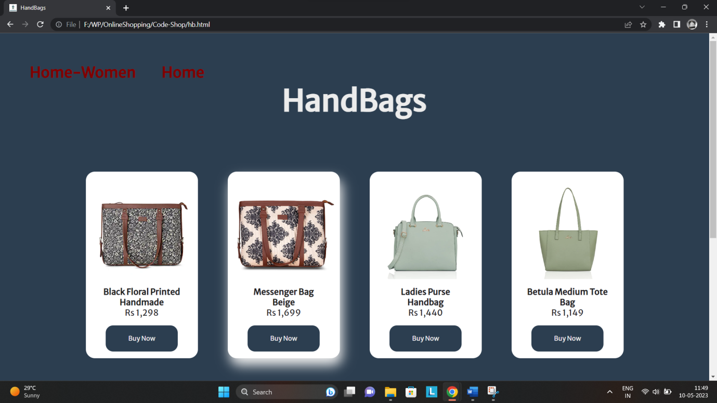

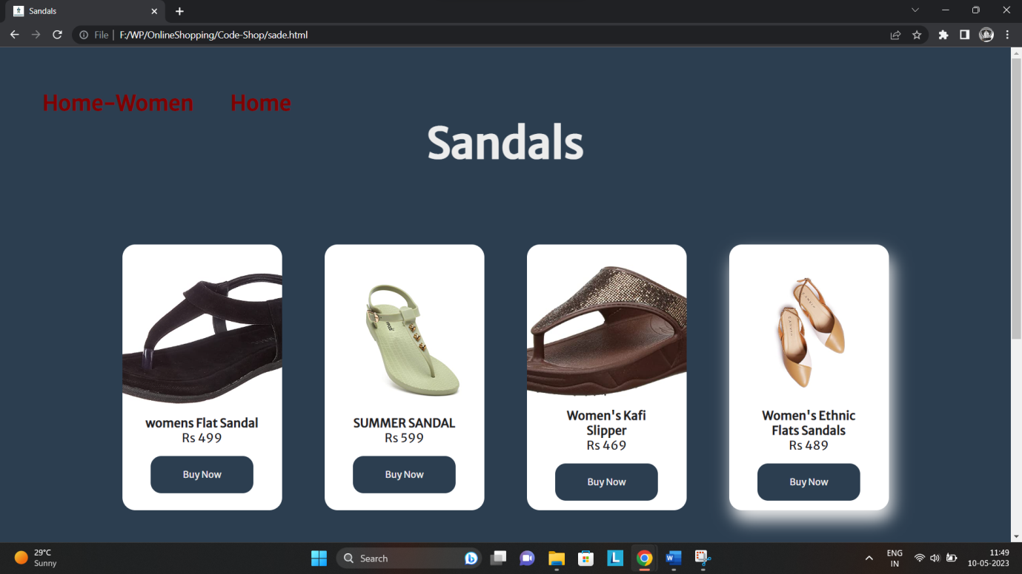

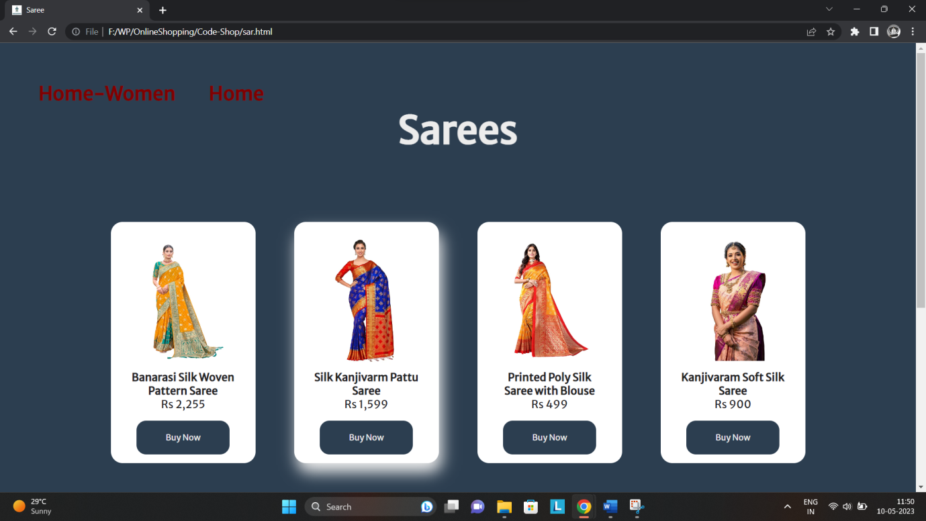

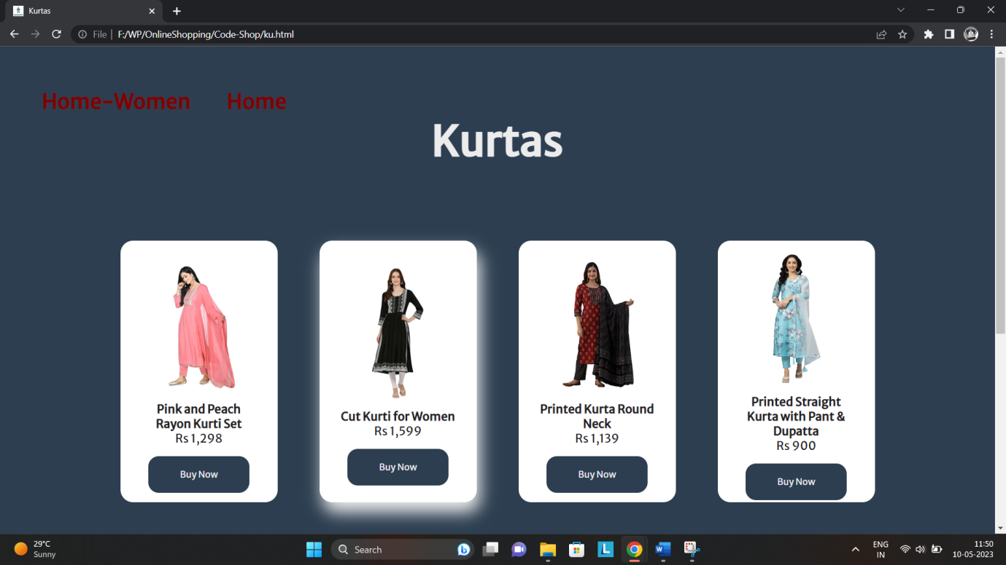

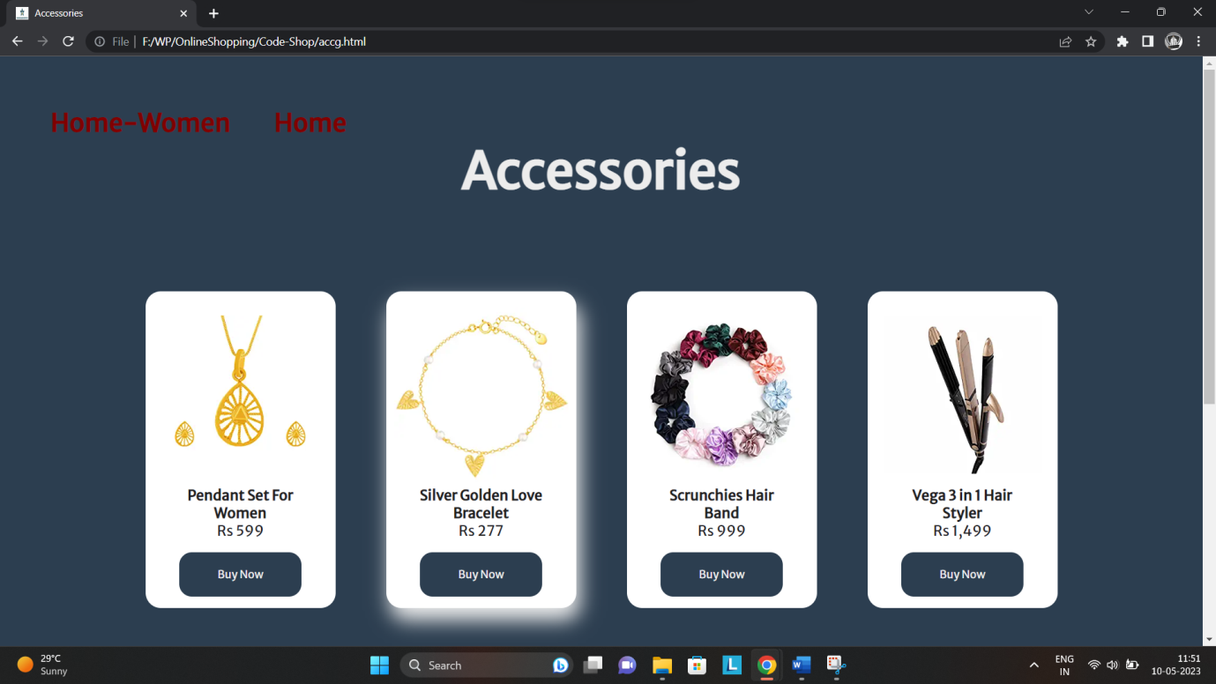

* **Fashion -> Kids:**

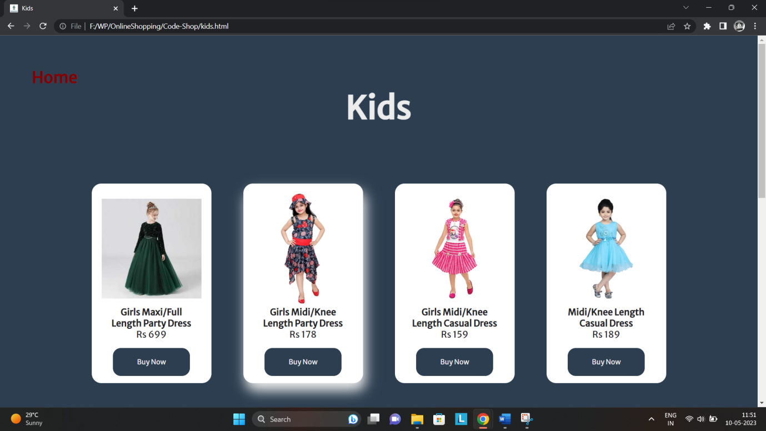

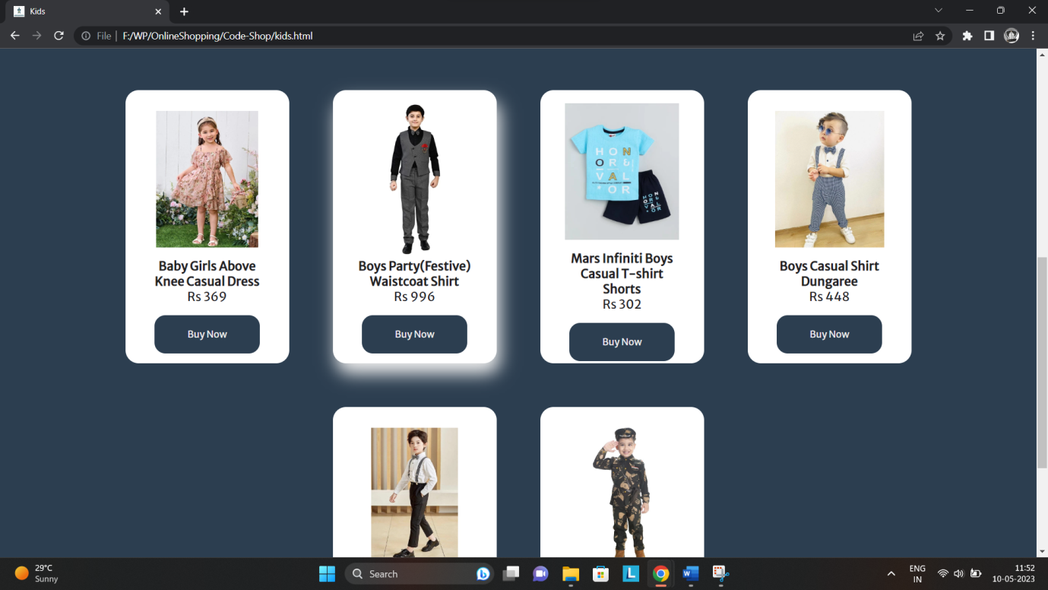

* **Customer Support:**

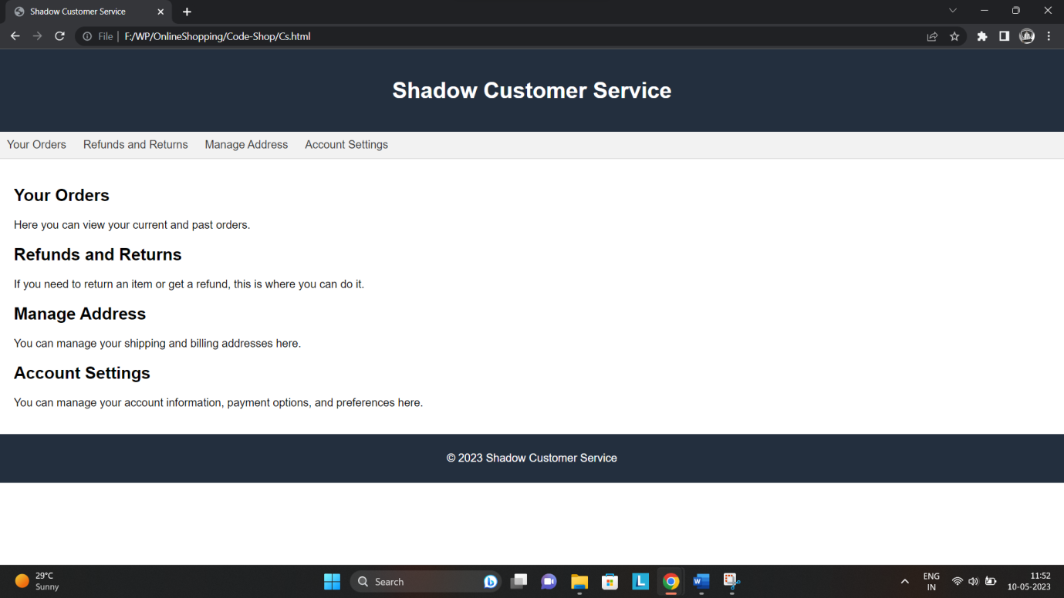

* **Signup page:**

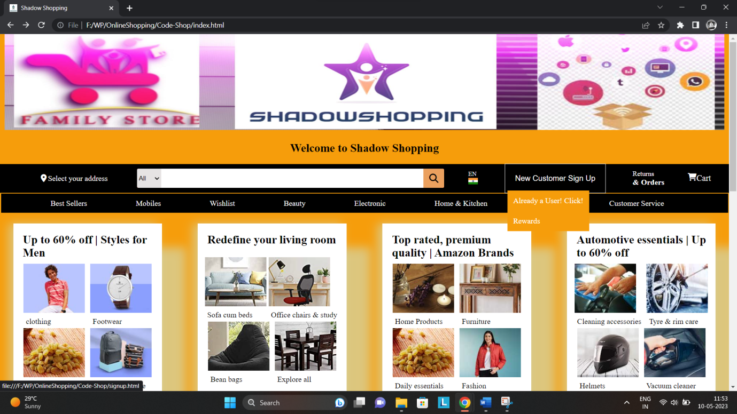

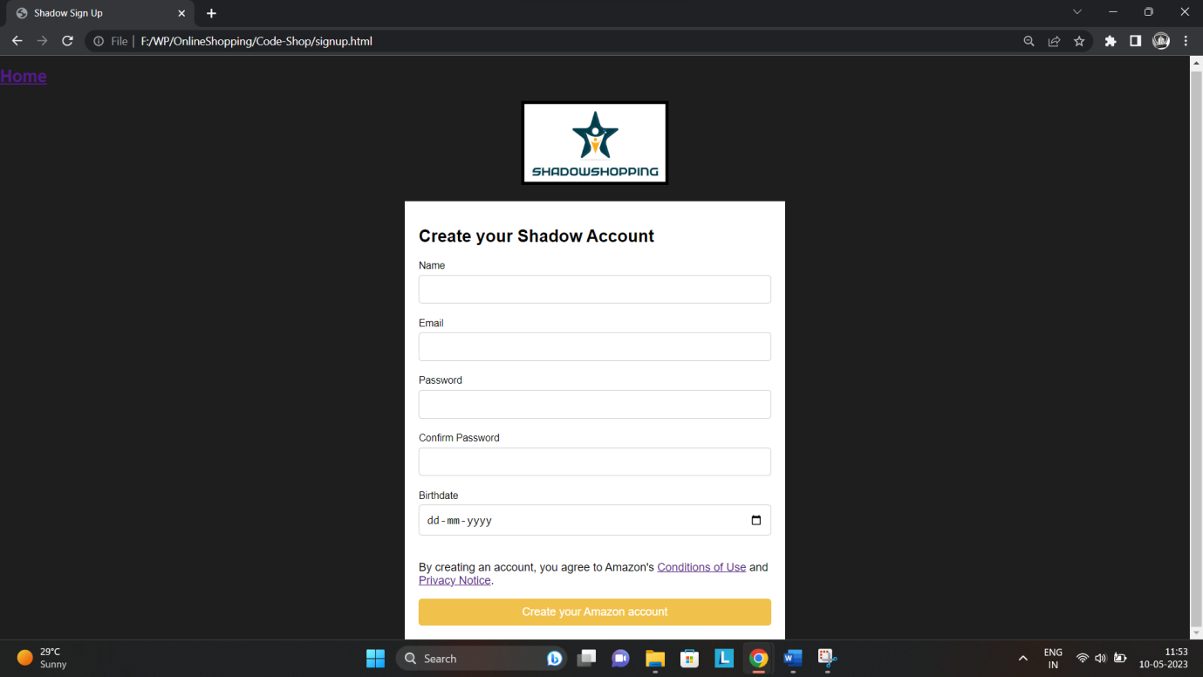

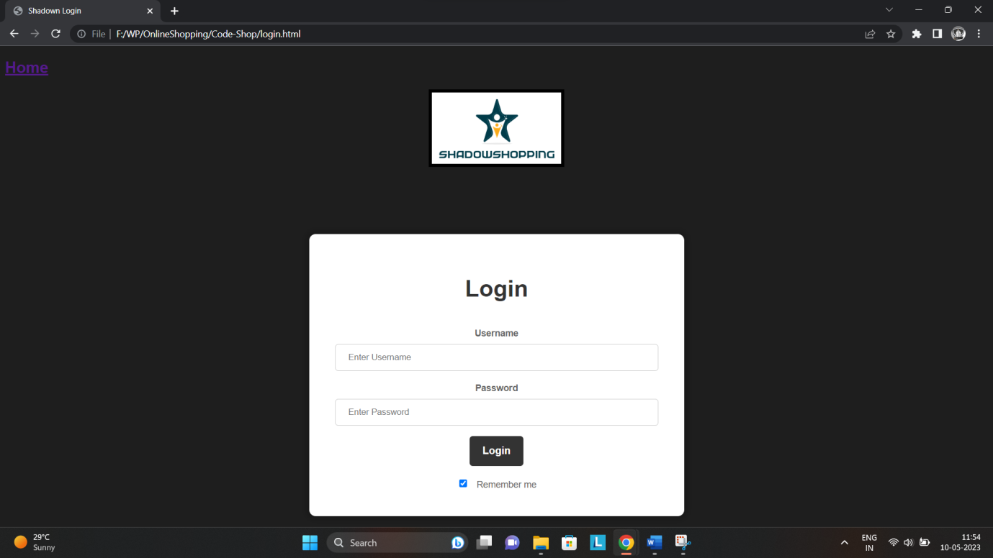

# **CHAPTER 4**

## **TESTING:**

The testing process for online shopping system website can involve multiple steps to ensure the website is functioning properly and providing a positive user experience. Here are some potential testing steps that could be taken:

* Unit Testing: Individual components and modules are tested to verify their proper functioning.
* Integration Testing: The integrated system is tested to ensure seamless communication interaction between different modules.
* User Acceptance Testing: Real users simulates scenarios to validate the system’s usability.
* Regression testing: repeatedly testing previously validated functionalities to ensure that changes or updates have not introduced any new errors.
* Performance Testing: This testing measures the website's speed and responsiveness, identifying any areas where the website may be slow or unresponsive and optimizing for faster loading times.

# **CHAPTER 5**

## **IMPLEMENTATION:**

The implementation of an online shopping system website can be broken down into several steps:

1. Planning and Research: In this stage, you need to identify the requirements of the project, including the target audience, features, and functionality needed in the website. You also need to research and gather information about competitors' websites and industry trends.
2. Design and Layout: After planning and research, the next step is to create a design and layout for the website. This includes deciding on the colour scheme, typography, navigation, and overall look and feel of the website.
3. Development: Once the design and layout are finalized, the website development can begin. This includes coding the website using HTML, CSS.
4. Content Creation: In this step, you need to create and upload all the content for the website, including the product details, images, and descriptions.
5. Testing and Debugging: Once the website is developed, it needs to be tested thoroughly to ensure that all the features and functionality work properly. This includes testing for usability, functionality, compatibility. Any bugs or issues found during the testing phase need to be fixed.
6. Launch: After the testing and debugging are completed, the website can be launched. This involves deploying the website to a web server.

# **Source Code:**

**Home Page:**

<!DOCTYPEhtml>

<htmllang="en">

<head>

    <metacharset="UTF-8">

    <metahttp-equiv="X-UA-Compatible"content="IE=edge">

    <metaname="viewport"content="width=device-width, initial-scale=1.0">

    <linkrel="icon"href="F:\WP\OnlineShopping\BG1.png"/>

    <title>Shadow Shopping</title>

    <!--css file-->

    <linkrel="stylesheet"href="style.css"/>

    <!--font awesome-->

    <linkrel="stylesheet"href="https://cdnjs.cloudflare.com/ajax/libs/font-awesome/6.2.0/css/all.min.css"

        integrity="sha512-xh6O/CkQoPOWDdYTDqeRdPCVd1SpvCA9XXcUnZS2FmJNp1coAFzvtCN9BmamE+4aHK8yyUHUSCcJHgXloTyT2A=="

        crossorigin="anonymous"referrerpolicy="no-referrer"/>

</head>

<center><imgsrc="F:\WP\OnlineShopping\ma.jpg"width="1500px"height="200px"></center>

<h2><center>Welcome to Shadow Shopping</center></h2>

<bodybgcolor="#F69D0B"></body>

<body>

    <headerclass="header">

        <divclass="container container-header">

            <divclass="logo-container border-white">

                <!--<div class="logo"></div>

                <span class="dotin"></span>-->

            </div>

            <divclass="address-container border-white">

                <divclass="icon-address">

                    <iclass="fa-solid fa-location-dot icon-location"></i>

                    <p>Select your address</p>

                </div>

            </div>

            <divclass="search-container">

                <selectclass="search-select">

                    <option>All</option>

                </select>

                <inputtype="text"class="search-input"/>

                <divclass="search-icon">

                    <iclass="fa-solid fa-magnifying-glass"></i>

                </div>

            </div>

            <divclass="language-container border-white">

                <p>EN</p>

                <divclass="lauguge-image">

                    <img

                        src="https://media.istockphoto.com/vectors/vector-flag-of-the-republic-of-india-proportion-23-the-national-flag-vector-id1051236720?k=20&m=1051236720&s=612x612&w=0&h=ATObRTHmTosADa9zaB2dQPn_VAQmG1XYH2x92kzc304="/>

                </div>

            </div>

            <divclass="dropdown border-white">

                <ahref="signup.html"style="text-decoration:none; color:white;">

                  <buttonclass="dropbtn">New Customer Sign Up</button>

                </a>

                <divclass="dropdown-content">

                  <ahref="login.html">Already a User! Click!</a>

                  <ahref="#">Rewards</a>

                </div>

            </div>

            <!--<div class="login-container border-white">

                <a href="login.html"  style="text-decoration:none; color:rgb(255, 255, 255);">Login</a>

            </div>-->

            <divclass="return-order-container border-white">

                <p>Returns

                <divclass="order">& Orders</div>

                </p>

            </div>

            <divclass="cart-container border-white">

                <iclass="fa-solid fa-cart-shopping"></i>

                Cart

            </div>

        </div>

    </header>

    <!--navigation-->

    <navclass="nav">

        <divclass="container container-nav">

            <ul>

                <liclass="border-white"><ahref="#">Best Sellers</a></li>

                <liclass="border-white"><ahref="mob.html">Mobiles</a></li>

                <liclass="border-white"><ahref="#">Wishlist</a></li>

                <liclass="border-white"><ahref="bea.html">Beauty</a></li>

                <liclass="border-white"><ahref="elm.html">Electronic</a></li>

                <liclass="border-white"><ahref="https://www.amazon.in/Home-Kitchen/b/?ie=UTF8&node=976442031&ref_=nav_cs_home">Home & Kitchen</a></li>

                <divclass="dd">

                    <liclass="border-white"><ahref="#">Fashion</a></li>

                        <divclass="dd-content">

                            <li><ahref="men.html">Men</a></li>

                            <li><ahref="women.html">Women</a></li>

                            <li><ahref="kids.html">Kids</a></li>

                        </div>

                </div>

                <liclass="border-white"><ahref="Cs.html">Customer Service</a></li>

                </li>

            </ul>

        </div>

    </nav>

    <!--product container card-->

    <mainclass="main">

        <divclass="card-product-container container">

            <divclass="card-product">

                <h2>Up to 60% off | Styles for Men</h2>

                <divclass="card-product-nested-card">

                    <divclass="card-nested">

                        <img

                            src="https://images-eu.ssl-images-amazon.com/images/G/31/img22/Fashion/Gateway/BAU/BTF-Refresh/May/PF_MF/MF-1-186-116._SY116_CB636110853_.jpg"/>

                        <p>clothing</p>

                    </div>

                    <divclass="card-nested">

                        <img

                            src="https://images-eu.ssl-images-amazon.com/images/G/31/img22/Fashion/Gateway/BAU/BTF-Refresh/May/PF_MF/MF-3-186-116._SY116_CB636110853_.jpg"/>

                        <p>Footwear</p>

                    </div>

                    <divclass="card-nested">

                        <img

                            src="https://images-eu.ssl-images-amazon.com/images/G/31/img22/BAU/Oct/186X116_3._SY116_CB606110532_.jpg"/>

                        <p>Watches</p>

                    </div>

                    <divclass="card-nested">

                        <img

                            src="https://images-eu.ssl-images-amazon.com/images/G/31/img22/Fashion/Gateway/BAU/BTF-Refresh/May/PF_MF/MF-4-186-116._SY116_CB636110853_.jpg"/>

                        <p>Bags & language</p>

                    </div>

                </div>

                <ahref="https://www.amazon.in/b/ref=sl_gw_feb20?node=6648217031&pf_rd_r=FY1E5FGX43MGXM58AN7G&pf_rd_p=133ffb74-b277-43b2-a112-f06d10e04e4c&pd_rd_r=d8001bd3-25bc-4467-9c52-3d83da620ffe&pd_rd_w=z5C2g&pd_rd_wg=6bhN2&ref_=pd_gw_unk"><buttonclass="card-product-btn">see more</button></a>

            </div>

            <divclass="card-product">

                <h2>Redefine your living room</h2>

                <divclass="card-product-nested-card">

                    <divclass="card-nested">

                        <img

                            src="https://images-eu.ssl-images-amazon.com/images/G/31/IMG20/Furniture/furniture_node_1/372_232_03_low._SY116_CB605507312_.jpg"/>

                        <p>Sofa cum beds</p>

                    </div>

                    <divclass="card-nested">

                        <img

                            src="https://images-eu.ssl-images-amazon.com/images/G/31/IMG20/Furniture/furniture_node_1/372_232_04_low._SY116_CB605507312_.jpg"/>

                        <p>Office chairs & study</p>

                    </div>

                    <divclass="card-nested">

                        <img

                            src="https://images-eu.ssl-images-amazon.com/images/G/31/IMG20/Furniture/furniture_node_1/372_232_01_low._SY116_CB605507312_.jpg"/>

                        <p>Bean bags</p>

                    </div>

                    <divclass="card-nested">

                        <img

                            src="https://images-eu.ssl-images-amazon.com/images/G/31/IMG20/Furniture/furniture_node_1/372_232_02_low._SY116_CB605507312_.jpg"/>

                        <p>Explore all</p>

                    </div>

                </div>

                <ahref="https://www.amazon.in/s?k=furnitures+for+home&sprefix=fur%2Caps%2C298&ref=nb_sb_ss_ts-doa-p_1_3"><buttonclass="card-product-btn">Visit our furniture store</button></a>

            </div>

            <divclass="card-product">

                <h2>Top rated, premium quality | Amazon Brands</h2>

                <divclass="card-product-nested-card">

                    <divclass="card-nested">

                        <img

                            src="https://images-eu.ssl-images-amazon.com/images/G/31/img22/BAU/Oct/186X116_1._SY116_CB606110532_.jpg"/>

                        <p>Home Products</p>

                    </div>

                    <divclass="card-nested">

                        <img

                            src="https://images-eu.ssl-images-amazon.com/images/G/31/img22/BAU/Oct/186X116_5._SY116_CB606110532_.jpg"/>

                        <p>Furniture</p>

                    </div>

                    <divclass="card-nested">

                        <img

                            src="https://images-eu.ssl-images-amazon.com/images/G/31/img22/BAU/Oct/186X116_3._SY116_CB606110532_.jpg"/>

                        <p>Daily essentials</p>

                    </div>

                    <divclass="card-nested">

                        <img

                            src="https://images-eu.ssl-images-amazon.com/images/G/31/img22/BAU/Oct/186X116_8._SY116_CB606110532_.jpg"/>

                        <p>Fashion</p>

                    </div>

                </div>

                <ahref="https://www.amazon.in/"><buttonclass="card-product-btn">see more</button></a>

            </div>

            <divclass="card-product">

                <h2>Automotive essentials | Up to 60% off</h2>

                <divclass="card-product-nested-card">

                    <divclass="card-nested">

                        <img

                            src="https://images-eu.ssl-images-amazon.com/images/W/IMAGERENDERING_521856-T2/images/G/31/img17/Auto/2020/GW/PCQC/Glasscare1X._SY116_CB410830553_.jpg"/>

                        <p>Cleaning accessories</p>

                    </div>

                    <divclass="card-nested">

                        <img

                            src="https://images-eu.ssl-images-amazon.com/images/W/IMAGERENDERING_521856-T2/images/G/31/img17/Auto/2020/GW/PCQC/Rim_tyrecare1x._SY116_CB410830552_.jpg"/>

                        <p>Tyre & rim care</p>

                    </div>

                    <divclass="card-nested">

                        <img

                            src="https://images-eu.ssl-images-amazon.com/images/W/IMAGERENDERING_521856-T2/images/G/31/img17/Auto/2020/GW/PCQC/Vega_helmet_186x116._SY116_CB405090404_.jpg"/>

                        <p>Helmets</p>

                    </div>

                    <divclass="card-nested">

                        <img

                            src="https://images-eu.ssl-images-amazon.com/images/W/IMAGERENDERING_521856-T2/images/G/31/img17/Auto/2020/GW/PCQC/Vaccum1x._SY116_CB410830552_.jpg"/>

                        <p>Vacuum cleaner</p>

                    </div>

                </div>

                <ahref="https://www.amazon.in/b?ie=UTF8&node=4772060031&pf_rd_r=MWY6BDVZW92TE9E6BJXX&pf_rd_p=9ff36f11-82d6-4600-a8fb-e52bb32e171c&pd_rd_r=8fa50fbc-15cc-45ae-8610-6a46fe5c766c&pd_rd_w=HGsFD&pd_rd_wg=bdTwH&ref_=pd_gw_unk/"><buttonclass="card-product-btn">see more</button></a>

            </div>

        </div>

        <divclass="card-product-container container">

            <divclass="card-product">

                <h2>Up to 60% off | Professional tools, testing & more</h2>

                <divclass="card-product-nested-card">

                    <divclass="card-nested">

                        <img

                            src="https://images-eu.ssl-images-amazon.com/images/W/IMAGERENDERING_521856-T2/images/G/31/img17/Biss/2018/QC/Tools1x._SY116_CB424026090_.jpg"/>

                        <p>Professional tools</p>

                    </div>

                    <divclass="card-nested">

                        <img

                            src="https://images-eu.ssl-images-amazon.com/images/W/IMAGERENDERING_521856-T2/images/G/31/img17/Biss/2021/BAU_GW_Graphics/PCQC/2._SY116_CB643952439_.jpg"/>

                        <p>Measuring instruments</p>

                    </div>

                    <divclass="card-nested">

                        <img

                            src="https://images-eu.ssl-images-amazon.com/images/W/IMAGERENDERING_521856-T2/images/G/31/img17/Biss/2021/BAU_GW_Graphics/PCQC/1._SY116_CB643952439_.jpg"/>

                        <p>Cleaning supplies</p>

                    </div>

                    <divclass="card-nested">

                        <img

                            src="https://images-eu.ssl-images-amazon.com/images/W/IMAGERENDERING_521856-T2/images/G/31/img17/Biss/2018/QC/med1x._SY116_CB424026091_.jpg"/>

                        <p>Medical supplies</p>

                    </div>

                </div>

                <ahref="https://www.amazon.in/"><buttonclass="card-product-btn">see more</button></a>

            </div>

            <divclass="card-product">

                <h2>Home appliances | Up to 55% off</h2>

                <divclass="card-product-nested-card">

                    <divclass="card-nested">

                        <img

                            src="https://images-eu.ssl-images-amazon.com/images/W/IMAGERENDERING_521856-T2/images/G/31/IMG15/Irfan/GATEWAY/MSO/Appliances-QC-PC-186x116--B08RDL6H79._SY116_CB667322346_.jpg"/>

                        <p>Air conditioners</p>

                    </div>

                    <divclass="card-nested">

                        <img

                            src="https://images-eu.ssl-images-amazon.com/images/W/IMAGERENDERING_521856-T2/images/G/31/IMG15/Irfan/GATEWAY/MSO/Appliances-QC-PC-186x116--B08345R1ZW._SY116_CB667322346_.jpg"/>

                        <p>Refrigerators</p>

                    </div>

                    <divclass="card-nested">

                        <img

                            src="https://images-eu.ssl-images-amazon.com/images/W/IMAGERENDERING_521856-T2/images/G/31/IMG15/Irfan/GATEWAY/MSO/Appliances-QC-PC-186x116--B07G5J5FYP._SY116_CB667322346_.jpg"/>

                        <p>Microwaves</p>

                    </div>

                    <divclass="card-nested">

                        <img

                            src="https://images-eu.ssl-images-amazon.com/images/W/IMAGERENDERING_521856-T2/images/G/31/IMG15/Irfan/GATEWAY/MSO/186x116---wm._SY116_CB667322346_.jpg"/>

                        <p>Washing machines</p>

                    </div>

                </div>

                <ahref="https://www.amazon.in/b?ie=UTF8&node=1380263031&ref=ATFQC_seeall&pf_rd_r=P9VKSMF50A12YFQ7M9CZ&pf_rd_p=e65dd5c7-e577-4370-85f3-d0c878dec2af&pd_rd_r=b95cac05-0f77-45b2-9ade-a24e3c743f01&pd_rd_w=UOl1N&pd_rd_wg=TFklo&ref_=pd_gw_unk"><buttonclass="card-product-btn">see more</button></a>

            </div>

            <divclass="card-product">

                <h2>Up to 60% off | Styles for women</h2>

                <divclass="card-product-nested-card">

                    <divclass="card-nested">

                        <img

                            src="https://images-eu.ssl-images-amazon.com/images/W/IMAGERENDERING_521856-T2/images/G/31/img22/Fashion/Gateway/BAU/BTF-Refresh/May/PC_WF/WF1-186-116._SY116_CB636048992_.jpg"/>

                        <p>Women's Clothing</p>

                    </div>

                    <divclass="card-nested">

                        <img

                            src="https://images-eu.ssl-images-amazon.com/images/W/IMAGERENDERING_521856-T2/images/G/31/img22/Fashion/Gateway/BAU/BTF-Refresh/May/PC_WF/WF2-186-116._SY116_CB636048992_.jpg"/>

                        <p>Footwear+handbags</p>

                    </div>

                    <divclass="card-nested">

                        <img

                            src="https://images-eu.ssl-images-amazon.com/images/W/IMAGERENDERING_521856-T2/images/G/31/img22/Fashion/Gateway/BAU/BTF-Refresh/May/PC_WF/WF4-186-116._SY116_CB636048992_.jpg"/>

                        <p>Watches</p>

                    </div>

                    <divclass="card-nested">

                        <img

                            src="https://images-eu.ssl-images-amazon.com/images/W/IMAGERENDERING_521856-T2/images/G/31/img22/Fashion/Gateway/BAU/BTF-Refresh/May/PC_WF/WF3-186-116._SY116_CB636048992_.jpg"/>

                        <p>Fashion jewellery</p>

                    </div>

                </div>

                <ahref="https://www.amazon.in/b/ref=sl_gw_feb20?node=6648217031&pf_rd_r=1XYRY1J88169WTSC0NYG&pf_rd_p=f8788599-321a-443a-b92d-87300482ee2d&pd_rd_r=88c7fa92-9864-483d-994a-8723801f8276&pd_rd_w=tEkx0&pd_rd_wg=Kmv0b&ref_=pd_gw_unk"><buttonclass="card-product-btn">see more</button></a>

            </div>

            <divclass="card-product">

                <h2>Up to 60% off | Home décor picks from local shops</h2>

                <divclass="card-product-nested-card">

                    <divclass="card-nested">

                        <img

                            src="https://m.media-amazon.com/images/W/IMAGERENDERING_521856-T2/images/I/812B6F8vJwL._AC_SY200_.jpg"/>

                        <!--<p>Professional tools</p>-->

                    </div>

                    <divclass="card-nested">

                        <img

                            src="https://m.media-amazon.com/images/W/IMAGERENDERING_521856-T2/images/I/61O5HoaOjCS._AC_SY200_.jpg"/>

                        <!--<p>Measuring instruments</p>-->

                    </div>

                    <divclass="card-nested">

                        <img

                            src="https://m.media-amazon.com/images/W/IMAGERENDERING_521856-T2/images/I/61Cbg262VQL._AC_SY200_.jpg"/>

                        <!--<p>Cleaning supplies</p>-->

                    </div>

                    <divclass="card-nested">

                        <img

                            src="https://m.media-amazon.com/images/W/IMAGERENDERING_521856-T2/images/I/415bAxzzGZL._AC_SY200_.jpg"/>

                        <!--<p>Medical supplies</p>-->

                    </div>

                </div>

                <ahref="https://www.amazon.in/l/22746077031?pd_rd_w=jt1cV&content-id=amzn1.sym.e7970c3d-28f7-40a3-a3cb-23beae0b0040&pf_rd_p=e7970c3d-28f7-40a3-a3cb-23beae0b0040&pf_rd_r=A3S4H0H96DMPY2YG20N8&pd_rd_wg=1lPye&pd_rd_r=7f62ff7b-37ca-4b3d-b94c-31ddd1a2155b"><buttonclass="card-product-btn">see more</button></a>

            </div>

        </div>

    <!--today's deals -->

    <sectionclass="today_deals_container">

        <divclass="today_deals_heading">

            <h1>Today's Deals</h1>

            <p><ahref="https://www.amazon.in/gp/goldbox/?ie=UTF8&ref=nav_topnav_deals&_ref=dlx_gate_sd_dcl_vai_dt&pd_rd_w=QC09F&content-id=amzn1.sym.a532052b-26f3-4811-a261-3b35ffa57237&pf_rd_p=a532052b-26f3-4811-a261-3b35ffa57237&pf_rd_r=19QHRTQ1TXJRV0VTEX13&pd_rd_wg=qJ8jh&pd_rd_r=3bcb64a0-5d9a-418c-9cc1-2ff21929893f&ref_=pd_gw_unk"><h3>See all deals</h3></a></p>

        </div>

        <divclass="today_deals_product_container">

            <divclass="today_deals_btn_container">

                <button  class="today_deal_btn"id="today_deal_btn_prev">

                    <iclass="fa-solid fa-angle-left"></i>

                </button>

                <buttonclass="today_deal_btn"id="today_deal_btn_next">

                    <iclass="fa-solid fa-angle-right"></i>

                </button>

            </div>

            <divclass="today_deals_product_list">

                <divclass="today_deals_product_item">

                    <imgsrc="https://m.media-amazon.com/images/I/411mbYGYIdL._AC_SY200_.jpg"/>

                    <divclass="discount_Contaienr">

                        <ahref="#">Up to 52% off</a>

                        <ahref="#">Deal of the day</a>

                    </div>

                    <p>adidas and Campus Footwear</p>

                </div>

                <divclass="today_deals_product_item">

                    <imgsrc="https://m.media-amazon.com/images/W/IMAGERENDERING_521856-T2/images/I/41ebGVIokuL._AC_SY200_.jpg"/>

                    <divclass="discount_Contaienr">

                        <ahref="#">Up to 52% off</a>

                        <ahref="#">Deal of the day</a>

                    </div>

                    <p>iQOO Z7 5G</p>

                </div>

                <divclass="today_deals_product_item">

                    <imgsrc="https://m.media-amazon.com/images/W/IMAGERENDERING_521856-T2/images/I/21pGfX7r8oL._AC_SY200_.jpg"/>

                    <divclass="discount_Contaienr">

                        <ahref="#">Up to 52% off</a>

                        <ahref="#">Deal of the day</a>

                    </div>

                    <p>Upto 60% off on Sony Headphones &…</p>

                </div>

                <divclass="today_deals_product_item">

                    <imgsrc="https://m.media-amazon.com/images/W/IMAGERENDERING_521856-T2/images/I/314vZxOio5L._AC_SY200_.jpg"/>

                    <divclass="discount_Contaienr">

                        <ahref="#">Up to 52% off</a>

                        <ahref="#">Deal of the day</a>

                    </div>

                    <p>MAD offers on Oppo Accessories</p>

                </div>

                <divclass="today_deals_product_item">

                    <imgsrc="https://m.media-amazon.com/images/I/31KkQr-bScL._AC_UF226,226_FMjpg_.jpg"/>

                    <divclass="discount_Contaienr">

                        <ahref="#">Up to 52% off</a>

                        <ahref="#">Deal of the day</a>

                    </div>

                    <p>High Performance Laptops</p>

                </div>

            </div>

        </div>

    </section>

    </main>

</body>

</html>

Electronics:

<!DOCTYPEhtml>

<html>

    <metacharset="utf-8">

    <metahttp-equiv="X-UA-Compatible"content="IE=edge">

    <metaname="viewport"content="width=device-width, initial-scale=1">

    <linkrel="icon"href="F:\WP\OnlineShopping\BG1.png"/>

    <title>Electronics</title>

<head>

    <scriptsrc="https://kit.fontawesome.com/e8fa2e31b4.js"crossorigin="anonymous"></script>

    <style>

        *{

            margin: 0;

            padding: 0;

            box-sizing: border-box;

            font-family: 'poppins', sans-serif;

        }

        body{

            display: flex;

            flex-direction: column;

            align-items: center;

            justify-content: center;

        }

        .top-bar{

            width: 80%;

            height: 4rem;

            background-color: #eee;

            margin-bottom: 20px;

            display: flex;

            padding: 0px20px;

            align-items: center;

            justify-content: space-between;

        }

        .fa-solid{

            color: red;

            margin-right: 10px;

        }

        .header{

            width: 80%;

            height: 20px;

            background-color: red;

            margin-bottom: 20px;

            padding: 20px;

            display: flex;

            flex-direction: column;

            justify-content: space-between;

        }

        .navbar{

            display: flex;

            justify-content: space-between;

            align-items: center;

        }

        .navbarp{

            font-size: 30px;

            font-weight: bold;

            color: white;

        }

        .navbarul{

            display: flex;

            list-style: none;

        }

        .navbarullia{

            text-decoration: none;

            font-size: 18px;

            color: white;

            padding: 7px15px;

        }

        .navbarullia:hover{

            background-color: white;

            color: red;

            border-radius: 3px;

        }

        .navbar-b{

            display: flex;

            align-items: center;

            justify-content: space-between;

        }

    </style>

<style>

    div.container {

      display:inline-block;

    }

    p {

      text-align:center;

    }

</style>

</head>

<body>

    <!--<dic class="top-bar">

        <p><i class="fa-solid fa-envelope"></i>ezlearnaxis@gmail.com</p>

        <p><i class="fa-solid fa-phone"></i>+923180000008</p>

    </dic>-->

    <divclass="header">

        <divclass="navbar">

            <ul>

                <li><ahref="index.html">Home</a></li>

            </ul>

        </div>

    </div>

    <divclass="container">

        <divid="root"></div>

    </div>

</body>

<bodybgcolor=""></body>

<body>

    <center><imgsrc="F:\WP\OnlineShopping\BG1.png"width="200"height="100"border="5"></center>

    <br>

    <br>

    <br>

    <center><divclass="container">

        <a>

            <ahref="elc.html"><imgsrc="F:\WP\OnlineShopping\elc\D1\D1.jpg"width="200"height="200"border="5"></a>

            <divstyle='width: 400px; text-align: center;'><b><h2>Desktop</h2></b></div>

        </a>

    </div>

    <divclass="container">

        <a>

            <ahref="spd.html"><imgsrc="F:\WP\OnlineShopping\elc\D2\D2.jpg"width="200"height="200"border="5"></a>

            <divstyle='width: 400px; text-align: center;'><b><h2>Speaker</h2></b></div>

        </a>

    </div>

    <divclass="container">

        <a>

            <ahref="sw.html"><imgsrc="F:\WP\OnlineShopping\elc\D3\D3.jpg"width="200"height="200"border="5"></a>

            <divstyle='width: 400px; text-align: center;'><b><h2>Smart watch</h2></b></div>

        </a>

    </div>

    <divclass="container">

        <a>

            <ahref="ph.html"><imgsrc="F:\WP\OnlineShopping\elc\D4\D4.jpg"width="200"height="200"border="5"></a>

            <divstyle='width: 400px; text-align: center;'><b><h2>Phone</h2></b></div>

        </a>

    </div>

    <divclass="container">

        <a>

            <ahref="tb.html"><imgsrc="F:\WP\OnlineShopping\elc\D5\D5.jpg"width="200"height="200"border="5"></a>

            <divstyle='width: 400px; text-align: center;'><b><h2>Tablets</h2></b></div>

        </a>

    </div>

    <divclass="container">

        <a>

            <ahref="ap.html"><imgsrc="F:\WP\OnlineShopping\elc\D6\D6.jpg"width="200"height="200"border="5"></a>

            <divstyle='width: 400px; text-align: center;'><b><h2>Airpods</h2></b></div>

        </a>

    </div>

    <divclass="container">

        <a>

            <ahref="hd.html"><imgsrc="F:\WP\OnlineShopping\elc\D7\D7.jpg"width="200"height="200"border="5"></a>

            <divstyle='width: 400px; text-align: center;'><b><h2>Headset</h2></b></div>

        </a>

    </div>

    <divclass="container">

        <a>

            <ahref="lap.html"><imgsrc="F:\WP\OnlineShopping\elc\D8\D8.jpg"width="200"height="200"border="5"></a>

            <divstyle='width: 400px; text-align: center;'><b><h2>Laptop</h2></b></div>

        </a>

    </div>

</center>

</body>

</html>

Beauty:

<!DOCTYPEhtml>

<html>

<head>

    <metacharset="utf-8">

    <metahttp-equiv="X-UA-Compatible"content="IE=edge">

    <metaname="viewport"content="width=device-width, initial-scale=1">

    <linkrel="icon"href="F:\WP\OnlineShopping\BG1.png"/>

    <title>Beauty Product</title>

    <linkrel="stylesheet"type="text/css"href="men.css">

</head>

<style>

    div.container {

      display:inline-block;

    }

    p {

      text-align:center;

    }

  </style>

<ul>

    <ahref="index.html"style="display:inline-block; text-decoration:none; color:Maroon; margin-right:80px;"><h3>Home</h3></a>

    <!--<center><imgsrc="F:\WP\OnlineShopping\BG1.png" width="200" height="150" border="5"></center>-->

</ul>

<body>

    <sectionclass="products">

        <h2>Beauty Products</h2>

        <divclass="all-products">

            <divclass="product">

                <imgsrc="F:\WP\OnlineShopping\Beauty\b1.jpg">

                <divclass="product-info">

                    <h4class="product-title">Mamaearth Onion Hair Fall Shampoo for Hair Growth

                    </h4>

                    <pclass="product-price">Rs 296</p>

                    <aclass="product-btn"href="https://amzn.eu/d/6ASVEDu">Buy Now</a>

                </div>

            </div>

            <divclass="product">

                <imgsrc="F:\WP\OnlineShopping\Beauty\b2.jpg">

                <divclass="product-info">

                    <h4class="product-title">Clinic Plus Strong & Long Shampoo 1 L, With Milk Proteins

                    </h4>

                    <pclass="product-price">Rs 530</p>

                    <aclass="product-btn"href="https://amzn.eu/d/bjGiz7u">Buy Now</a>

                </div>

            </div>

            <divclass="product">

                <imgsrc="F:\WP\OnlineShopping\Beauty\b3.jpg">

                <divclass="product-info">

                    <h4class="product-title">AL'OréalProfessionnel Absolut Repair Shampoo For Damaged

                    </h4>

                    <pclass="product-price">Rs 745</p>

                    <aclass="product-btn"href="https://amzn.eu/d/0iVeQco">Buy Now</a>

                </div>

            </div>

            <divclass="product">

                <imgsrc="F:\WP\OnlineShopping\Beauty\b4.jpg">

                <divclass="product-info">

                    <h4class="product-title">L'Oreal Paris Moisture Filling Shampoo, With Hyaluronic Acid

                        </h4>

                    <pclass="product-price">Rs 198</p>

                    <aclass="product-btn"href="https://amzn.eu/d/62hZJNv">Buy Now</a>

                </div>

            </div>

            <divclass="product">

                <imgsrc="F:\WP\OnlineShopping\Beauty\b5.jpg">

                <divclass="product-info">

                    <h4class="product-title">Dove Hair Fall Rescue Shampoo For Weak Hair, 1 Ltr

                    </h4>

                    <pclass="product-price">Rs 795</p>

                    <aclass="product-btn"href="https://dl.flipkart.com/s/3KIevkNNNN">Buy Now</a>

                </div>

            </div>

            <divclass="product">

                <imgsrc="F:\WP\OnlineShopping\Beauty\b6.jpg">

                <divclass="product-info">

                    <h4class="product-title">L'Oréal ProfessionnelXtenso Care Shampoo For Straightened Hair, 250 ML

                        </h4>

                    <pclass="product-price">Rs 603</p>

                    <aclass="product-btn"href="https://dl.flipkart.com/s/3Kakq1NNNN">Buy Now</a>

                </div>

            </div>

            <divclass="product">

                <imgsrc="F:\WP\OnlineShopping\Beauty\b7.jpg">

                <divclass="product-info">

                    <h4class="product-title">L’Oréal Professionnel Scalp Advanced Anti-Dandruff Dermo-Clarifier Shampoo 300 Ml

                    </h4>

                    <pclass="product-price">Rs 695</p>

                    <aclass="product-btn"href="https://dl.flipkart.com/s/3KIevkNNNN">Buy Now</a>

                </div>

            </div>

            <divclass="product">

                <imgsrc="F:\WP\OnlineShopping\Beauty\b8.jpg">

                <divclass="product-info">

                    <h4class="product-title">Garnier Skin Naturals, Face Serum, Increases Skin's Glow Instantly

                        </h4>

                    <pclass="product-price">Rs 448</p>

                    <aclass="product-btn"href="https://dl.flipkart.com/s/3Kakq1NNNN">Buy Now</a>

                </div>

            </div>

            <divclass="product">

                <imgsrc="F:\WP\OnlineShopping\Beauty\b9.jpg">

                <divclass="product-info">

                    <h4class="product-title">Nivea Soft Light Moisturizer For Face, Hand & Body

                    </h4>

                    <pclass="product-price">Rs 197</p>

                    <aclass="product-btn"href="https://dl.flipkart.com/s/3KIevkNNNN">Buy Now</a>

                </div>

            </div>

            <divclass="product">

                <imgsrc="F:\WP\OnlineShopping\Beauty\b10.jpg">

                <divclass="product-info">

                    <h4class="product-title">Fogg Scent Prince 30 ml

                        </h4>

                    <pclass="product-price">Rs 140</p>

                    <aclass="product-btn"href="https://dl.flipkart.com/s/3Kakq1NNNN">Buy Now</a>

                </div>

            </div>

            <divclass="product">

                <imgsrc="F:\WP\OnlineShopping\Beauty\b11.jpg">

                <divclass="product-info">

                    <h4class="product-title">Nivea Fresh Active Deodorant Roll On For Men, 50ml

                    </h4>

                    <pclass="product-price">Rs 133</p>

                    <aclass="product-btn"href="https://dl.flipkart.com/s/3KIevkNNNN">Buy Now</a>

                </div>

            </div>

            <divclass="product">

                <imgsrc="F:\WP\OnlineShopping\Beauty\b12.jpg">

                <divclass="product-info">

                    <h4class="product-title">SET WET Deodorant Spray Perfume Cool, Charm

                        </h4>

                    <pclass="product-price">Rs 273</p>

                    <aclass="product-btn"href="https://dl.flipkart.com/s/3Kakq1NNNN">Buy Now</a>

                </div>

            </div>

            <divclass="product">

                <imgsrc="F:\WP\OnlineShopping\Beauty\b13.jpg">

                <divclass="product-info">

                    <h4class="product-title">MamaearthUbtan Natural Face Wash for All Skin Type with Turmeric

                    </h4>

                    <pclass="product-price">Rs 220</p>

                    <aclass="product-btn"href="https://dl.flipkart.com/s/3KIevkNNNN">Buy Now</a>

                </div>

            </div>

            <divclass="product">

                <imgsrc="F:\WP\OnlineShopping\Beauty\b14.jpg">

                <divclass="product-info">

                    <h4class="product-title">Maybelline New York Colossal Kajal

                        </h4>

                    <pclass="product-price">Rs 168</p>

                    <aclass="product-btn"href="https://dl.flipkart.com/s/3Kakq1NNNN">Buy Now</a>

                </div>

            </div>

            <divclass="product">

                <imgsrc="F:\WP\OnlineShopping\Beauty\b15.jpg">

                <divclass="product-info">

                    <h4class="product-title">Vega Premium Eye Lash Curler

                    </h4>

                    <pclass="product-price">Rs 177</p>

                    <aclass="product-btn"href="https://dl.flipkart.com/s/3KIevkNNNN">Buy Now</a>

                </div>

            </div>

            <divclass="product">

                <imgsrc="F:\WP\OnlineShopping\Beauty\b16.jpg">

                <divclass="product-info">

                    <h4class="product-title">Colorbar Blend-Itude Makeup Sponge, Pinkv

                        </h4>

                    <pclass="product-price">Rs 139</p>

                    <aclass="product-btn"href="https://dl.flipkart.com/s/3Kakq1NNNN">Buy Now</a>

                </div>

            </div>

            <divclass="product">

                <imgsrc="F:\WP\OnlineShopping\Beauty\b17.jpg">

                <divclass="product-info">

                    <h4class="product-title">ASUS VivoBook 14 (2021) Celeron Dual Core - (4 GB/256 GB SSD/Windows 11 Home)

                    </h4>

                    <pclass="product-price">Rs 21,990</p>

                    <aclass="product-btn"href="https://dl.flipkart.com/s/3KIevkNNNN">Buy Now</a>

                </div>

            </div>

            <divclass="product">

                <imgsrc="F:\WP\OnlineShopping\Beauty\b18.jpg">

                <divclass="product-info">

                    <h4class="product-title">HP Athlon Dual Core 3050U - (8 GB/256 GB SSD/Windows 11 Home)

                        </h4>

                    <pclass="product-price">Rs 25,999</p>

                    <aclass="product-btn"href="https://dl.flipkart.com/s/3Kakq1NNNN">Buy Now</a>

                </div>

            </div>

            <divclass="product">

                <imgsrc="F:\WP\OnlineShopping\Beauty\b19.jpg">

                <divclass="product-info">

                    <h4class="product-title">ASUS VivoBook 14 (2021) Celeron Dual Core - (4 GB/256 GB SSD/Windows 11 Home)

                    </h4>

                    <pclass="product-price">Rs 21,990</p>

                    <aclass="product-btn"href="https://dl.flipkart.com/s/3KIevkNNNN">Buy Now</a>

                </div>

            </div>

            <divclass="product">

                <imgsrc="F:\WP\OnlineShopping\Beauty\b20.jpg">

                <divclass="product-info">

                    <h4class="product-title">HP Athlon Dual Core 3050U - (8 GB/256 GB SSD/Windows 11 Home)

                        </h4>

                    <pclass="product-price">Rs 25,999</p>

                    <aclass="product-btn"href="https://dl.flipkart.com/s/3Kakq1NNNN">Buy Now</a>

                </div>

            </div>

        </div>

    </section>

</body>

</html>

Men, women and Kids:

<!DOCTYPEhtml>

<html>

<head>

    <title>Men</title>

    <metacharset="utf-8">

    <metahttp-equiv="X-UA-Compatible"content="IE=edge">

    <metaname="viewport"content="width=device-width, initial-scale=1">

    <linkrel="icon"href="F:\WP\OnlineShopping\BG1.png"/>

    <scriptsrc="https://kit.fontawesome.com/e8fa2e31b4.js"crossorigin="anonymous"></script>

    <style>

        *{

            margin: 0;

            padding: 0;

            box-sizing: border-box;

            font-family: 'poppins', sans-serif;

        }

        body{

            display: flex;

            flex-direction: column;

            align-items: center;

            justify-content: center;

        }

        .top-bar{

            width: 80%;

            height: 4rem;

            background-color: #eee;

            margin-bottom: 20px;

            display: flex;

            padding: 0px20px;

            align-items: center;

            justify-content: space-between;

        }

        .fa-solid{

            color: red;

            margin-right: 10px;

        }

        .header{

            width: 80%;

            height: 20px;

            background-color: red;

            margin-bottom: 20px;

            padding: 20px;

            display: flex;

            flex-direction: column;

            justify-content: space-between;

        }

        .navbar{

            display: flex;

            justify-content: space-between;

            align-items: center;

        }

        .navbarp{

            font-size: 30px;

            font-weight: bold;

            color: white;

        }

        .navbarul{

            display: flex;

            list-style: none;

        }

        .navbarullia{

            text-decoration: none;

            font-size: 18px;

            color: white;

            padding: 7px15px;

        }

        .navbarullia:hover{

            background-color: white;

            color: red;

            border-radius: 3px;

        }

        .navbar-b{

            display: flex;

            align-items: center;

            justify-content: space-between;

        }

    </style>

<style>

    div.container {

      display:inline-block;

    }

    p {

      text-align:center;

    }

</style>

</head>

<body>

    <!--<dic class="top-bar">

        <p><i class="fa-solid fa-envelope"></i>ezlearnaxis@gmail.com</p>

        <p><i class="fa-solid fa-phone"></i>+923180000008</p>

    </dic>-->

    <divclass="header">

        <divclass="navbar">

            <ul>

                <li><ahref="index.html">Home</a></li>

            </ul>

        </div>

    </div>

    <divclass="container">

        <divid="root"></div>

    </div>

</body>

<bodybgcolor="white"></body>

<body>

    <center><imgsrc="F:\WP\OnlineShopping\BG1.png"width="200"height="100"border="5"></center>

    <br>

    <br>

    <br>

    <center><divclass="container">

        <a>

            <ahref="shirt.html"><imgsrc="F:\WP\OnlineShopping\Mens\shirt\shirt.png"width="200"height="200"border="5"></a>

            <divstyle='width: 400px; text-align: center;'><b><h2>Shirts</h2></b></div>

        </a>

    </div>

    <divclass="container">

        <a>

            <ahref="tshirt.html"><imgsrc="F:\WP\OnlineShopping\Mens\tshirt\tshirt.png"width="200"height="200"border="5"></a>

            <divstyle='width: 400px; text-align: center;'><b><h2>TShirts</h2></b></div>

        </a>

    </div>

    <divclass="container">

        <a>

            <ahref="jeans.html"><imgsrc="F:\WP\OnlineShopping\Mens\jeans\jeans.png"width="200"height="200"border="5"></a>

            <divstyle='width: 400px; text-align: center;'><b><h2>Jeans</h2></b></div>

        </a>

    </div>

    <divclass="container">

        <a>

            <ahref="shoes.html"><imgsrc="F:\WP\OnlineShopping\Mens\shoes\shoes.png"width="200"height="200"border="5"></a>

            <divstyle='width: 400px; text-align: center;'><b><h2>Shoes</h2></b></div>

        </a>

    </div>

    <divclass="container">

        <a>

            <ahref="ffs.html"><imgsrc="F:\WP\OnlineShopping\Mens\ffs\ffs.png"width="200"height="200"border="5"></a>

            <divstyle='width: 400px; text-align: center;'><b><h2>FlipFlops</h2></b></div>

        </a>

    </div>

    <divclass="container">

        <a>

            <ahref="acc.html"><imgsrc="F:\WP\OnlineShopping\Mens\access\access.png"width="200"height="200"border="5"></a>

            <divstyle='width: 400px; text-align: center;'><b><h2>Accessories</h2></b></div>

        </a>

    </div>

    <divclass="container">

        <a>

            <ahref="tdm.html"><imgsrc="F:\WP\OnlineShopping\Mens\td\td.png"width="128"height="460"border="5"></a>

            <divstyle='width: 400px; text-align: center;'><b><h2>Traditional Dress</h2></b></div>

        </a>

    </div>

</center>

</body>

</html>

<!DOCTYPEhtml>

<html>

<head>

    <title>Women</title>

    <metacharset="utf-8">

    <metahttp-equiv="X-UA-Compatible"content="IE=edge">

    <metaname="viewport"content="width=device-width, initial-scale=1">

    <linkrel="icon"href="F:\WP\OnlineShopping\BG1.png"/>

    <scriptsrc="https://kit.fontawesome.com/e8fa2e31b4.js"crossorigin="anonymous"></script>

    <style>

        *{

            margin: 0;

            padding: 0;

            box-sizing: border-box;

            font-family: 'poppins', sans-serif;

        }

        body{

            display: flex;

            flex-direction: column;

            align-items: center;

            justify-content: center;

        }

        .top-bar{

            width: 80%;

            height: 4rem;

            background-color: #eee;

            margin-bottom: 20px;

            display: flex;

            padding: 0px20px;

            align-items: center;

            justify-content: space-between;

        }

        .fa-solid{

            color: red;

            margin-right: 10px;

        }

        .header{

            width: 80%;

            height: 20px;

            background-color: red;

            margin-bottom: 20px;

            padding: 20px;

            display: flex;

            flex-direction: column;

            justify-content: space-between;

        }

        .navbar{

            display: flex;

            justify-content: space-between;

            align-items: center;

        }

        .navbarp{

            font-size: 30px;

            font-weight: bold;

            color: white;

        }

        .navbarul{

            display: flex;

            list-style: none;

        }

        .navbarullia{

            text-decoration: none;

            font-size: 18px;

            color: white;

            padding: 7px15px;

        }

        .navbarullia:hover{

            background-color: white;

            color: red;

            border-radius: 3px;

        }

        .navbar-b{

            display: flex;

            align-items: center;

            justify-content: space-between;

        }

    </style>

<style>

    div.container {

      display:inline-block;

    }

    p {

      text-align:center;

    }

</style>

</head>

<body>

    <!--<dic class="top-bar">

        <p><i class="fa-solid fa-envelope"></i>ezlearnaxis@gmail.com</p>

        <p><i class="fa-solid fa-phone"></i>+923180000008</p>

    </dic>-->

    <divclass="header">

        <divclass="navbar">

            <ul>

                <li><ahref="index.html">Home</a></li>

            </ul>

        </div>

    </div>

    <divclass="container">

        <divid="root"></div>

    </div>

</body>

<bodybgcolor="white"></body>

<body>

    <center><imgsrc="F:\WP\OnlineShopping\BG1.png"width="200"height="100"border="5"></center>

    <br>

    <br>

    <br>

    <center>

    <divclass="container">

        <a>

            <ahref="gsho.html"><imgsrc="F:\WP\OnlineShopping\Womens\shoesgl.png"width="200"height="200"border="5"></a>

            <divstyle='width: 400px; text-align: center;'><b><h2>Shoes</h2></b></div>

        </a>

    </div>

    <divclass="container">

        <a>

                <ahref="hb.html"><imgsrc="F:\WP\OnlineShopping\Womens\hb.png"width="214"height="134"border="5"></a>

                <divstyle='width: 400px; text-align: center;'><b><h2>HandBags</h2></b></div>

        </a>

    </div>

    <divclass="container">

        <a>

            <ahref="sade.html"><imgsrc="F:\WP\OnlineShopping\Womens\sade.png"width="200"height="200"border="5"></a>

            <divstyle='width: 400px; text-align: center;'><b><h2>Sandals</h2></b></div>

        </a>

    </div>

    <divclass="container">

        <a>

            <ahref="sar.html"><imgsrc="F:\WP\OnlineShopping\Womens\saree.png"width="114"height="321"border="5"></a>

            <divstyle='width: 400px; text-align: center;'><b><h2>Saree</h2></b></div>

        </a>

    </div>

    <divclass="container">

        <a>

            <ahref="ku.html"><imgsrc="F:\WP\OnlineShopping\Womens\ku.png"width="184"height="321"border="5"></a>

            <divstyle='width: 400px; text-align: center;'><b><h2>Kurta</h2></b></div>

        </a>

    </div>

    <divclass="container">

        <a>

            <ahref="accg.html"><imgsrc="F:\WP\OnlineShopping\Womens\accessgl.png"width="222"height="51"border="5"></a>

            <divstyle='width: 400px; text-align: center;'><b><h2>Accessories</h2></b></div>

        </a>

    </div>

</center>

</body>

</html>

<!DOCTYPEhtml>

<html>

<head>

    <metacharset="utf-8">

    <metahttp-equiv="X-UA-Compatible"content="IE=edge">

    <metaname="viewport"content="width=device-width, initial-scale=1">

    <linkrel="icon"href="F:\WP\OnlineShopping\BG1.png"/>

    <title>Kids</title>

    <linkrel="stylesheet"type="text/css"href="men.css">

</head>

<style>

    div.container {

      display:inline-block;

    }

    p {

      text-align:center;

    }

  </style>

<ul>

    <ahref="index.html"style="display:inline-block; text-decoration:none; color:Maroon; margin-right:80px;"><h3>Home</h3></a>

    <!--<center><imgsrc="F:\WP\OnlineShopping\BG1.png" width="200" height="150" border="5"></center>-->

</ul>

<body>

   <sectionclass="products">

    <h2>Kids</h2>

    <divclass="all-products">

        <divclass="product">

            <imgsrc="F:\WP\OnlineShopping\Kids\kd1.jpg">

            <divclass="product-info">

                <h4class="product-title">Girls Maxi/Full Length Party Dress

                </h4>

                <pclass="product-price">Rs 699</p>

                <aclass="product-btn"href="https://dl.flipkart.com/s/px1q6ruuuN">Buy Now</a>

            </div>

        </div>

        <divclass="product">

            <imgsrc="F:\WP\OnlineShopping\Kids\kd2.jpg">

            <divclass="product-info">

                <h4class="product-title">Girls Midi/Knee Length Party Dress

                </h4>

                <pclass="product-price">Rs 178</p>

                <aclass="product-btn"href="https://dl.flipkart.com/s/lXbCjguuuN">Buy Now</a>

            </div>

        </div>

        <divclass="product">

            <imgsrc="F:\WP\OnlineShopping\Kids\kd3.jpg">

            <divclass="product-info">

                <h4class="product-title">Girls Midi/Knee Length Casual Dress

                </h4>

                <pclass="product-price">Rs 159</p>

                <aclass="product-btn"href="https://dl.flipkart.com/s/lX3FdguuuN">Buy Now</a>

            </div>

        </div>

        <divclass="product">

            <imgsrc="F:\WP\OnlineShopping\Kids\kd4.jpg">

            <divclass="product-info">

                <h4class="product-title">Midi/Knee Length Casual Dress

                    </h4>

                <pclass="product-price">Rs 189</p>

                <aclass="product-btn"href="https://dl.flipkart.com/s/lXEkwXuuuN">Buy Now</a>

            </div>

        </div>

        <divclass="product">

            <imgsrc="F:\WP\OnlineShopping\Kids\kd5.jpg">

            <divclass="product-info">

                <h4class="product-title">Baby Girls Above Knee Casual Dress

                    </h4>

                <pclass="product-price">Rs 369</p>

                <aclass="product-btn"href="https://dl.flipkart.com/s/lXWfPguuuN">Buy Now</a>

            </div>

        </div>

        <divclass="product">

            <imgsrc="F:\WP\OnlineShopping\Kids\kd6.jpg">

            <divclass="product-info">

                <h4class="product-title">Boys Party(Festive) Waistcoat Shirt

                    </h4>

                <pclass="product-price">Rs 996</p>

                <aclass="product-btn"href="https://dl.flipkart.com/s/WFfi3JNNNN">Buy Now</a>

            </div>

        </div>

        <divclass="product">

            <imgsrc="F:\WP\OnlineShopping\Kids\kd7.jpg">

            <divclass="product-info">

                <h4class="product-title">Mars Infiniti Boys Casual T-shirt Shorts

                    </h4>

                <pclass="product-price">Rs 302</p>

                <aclass="product-btn"href="https://dl.flipkart.com/s/WFfh!wNNNN">Buy Now</a>

            </div>

        </div>

        <divclass="product">

            <imgsrc="F:\WP\OnlineShopping\Kids\kd8.jpg">

            <divclass="product-info">

                <h4class="product-title">Boys Casual Shirt Dungaree

                    </h4>

                <pclass="product-price">Rs 448</p>

                <aclass="product-btn"href="https://dl.flipkart.com/s/WFIMUJNNNN">Buy Now</a>

            </div>

        </div>

        <divclass="product">

            <imgsrc="F:\WP\OnlineShopping\Kids\kd9.jpg">

            <divclass="product-info">

                <h4class="product-title">Boys Casual Shirt and Pant

                    </h4>

                <pclass="product-price">Rs 599</p>

                <aclass="product-btn"href="https://dl.flipkart.com/s/lXF8!9uuuN">Buy Now</a>

            </div>

        </div>

        <divclass="product">

            <imgsrc="F:\WP\OnlineShopping\Kids\kd10.jpg">

            <divclass="product-info">

                <h4class="product-title">Boys Casual Shirt Pant,Cap

                    </h4>

                <pclass="product-price">Rs 317</p>

                <aclass="product-btn"href="https://dl.flipkart.com/s/lX9zUXuuuN">Buy Now</a>

            </div>

        </div>

    </div>

</section>

</body>

</html>

**CSS code used for products page:**

@importurl('https://fonts.googleapis.com/css2?family=Merriweather+Sans&display=swap');

*{

    margin: 0;

    padding: 0;

    box-sizing: border-box;

}

body{

    font-size: 1.7rem;

    font-family: 'Merriweather Sans', sans-serif;

    background: #2c3e50;

    color: #ececec;

    padding: 4rem;

}

h2{

    text-align: center;

    margin-bottom: 5rem;

    font-size: 4rem;

}

.all-products{

    display: flex;

    align-items: center;

    justify-content: center;

    flex-wrap: wrap;

}

.product{

    overflow: hidden;

    background: #ffffff;

    color: #21201e;

    text-align: center;

    width: 240px;

    height: 400px;

    padding: 2rem;

    display: flex;

    flex-direction: column;

    align-items: center;

    justify-content: center;

    border-radius: 1.2rem;

    margin: 2rem;

}

.product.product-title, .product.product-price{

    font-size: 18px;

}

.product:hoverimg{

    scale:  1.1;

}

.product:hover {

    box-shadow: 5px15px25px#eeeeee;

}

.productimg {

    height: 200px;

    margin: 1rem;

    transition: all0.3s;

}

.producta:link, .producta:visited{

    color: #ececec;

    display: inline-block;

    text-decoration: none;

    background-color: #2c3e50;

    padding: 1.2rem3rem;

    border-radius: 1rem;

    margin-top: 1rem;

    font-size: 14px;

    transition: all0.2s;

}

.producta:hover{

    transform: scale(1.1);

}

<!DOCTYPEhtml>

<html>

<head>

    <metacharset="utf-8">

    <metahttp-equiv="X-UA-Compatible"content="IE=edge">

    <metaname="viewport"content="width=device-width, initial-scale=1">

    <linkrel="icon"href="F:\WP\OnlineShopping\BG1.png"/>

    <title>Shirt</title>

    <linkrel="stylesheet"type="text/css"href="men.css">

</head>

<style>

    div.container {

      display:inline-block;

    }

    p {

      text-align:center;

    }

  </style>

<ul>

    <ahref="men.html"style="display:inline-block; text-decoration:none; color:maroon; margin-right:50px;"><h3>Home-Men</h3></a>

    <ahref="index.html"style="display:inline-block; text-decoration:none; color:Maroon; margin-right:80px;"><h3>Home</h3></a>

    <!--<center><imgsrc="F:\WP\OnlineShopping\BG1.png" width="200" height="150" border="5"></center>-->

</ul>

<body>

    <sectionclass="products">

        <h2>Shirts</h2>

        <divclass="all-products">

            <divclass="product">

                <imgsrc="F:\WP\OnlineShopping\Mens\shirt\1.png">

                <divclass="product-info">

                    <h4class="product-title">Men's Regular Fit Casual Shirt

                    </h4>

                    <pclass="product-price">Rs 709</p>

                    <aclass="product-btn"href="https://amzn.eu/d/iL24Bzq">Buy Now</a>

                </div>

            </div>

            <divclass="product">

                <imgsrc="F:\WP\OnlineShopping\Mens\shirt\2.png">

                <divclass="product-info">

                    <h4class="product-title">Allen Solly Men's Slim Fit Shirt

                    </h4>

                    <pclass="product-price">Rs 699</p>

                    <aclass="product-btn"href="https://amzn.eu/d/55lLMmb">Buy Now</a>

                </div>

            </div>

            <divclass="product">

                <imgsrc="F:\WP\OnlineShopping\Mens\shirt\3.png">

                <divclass="product-info">

                    <h4class="product-title">Peter England Men Shirt

                    </h4>

                    <pclass="product-price">Rs 709</p>

                    <aclass="product-btn"href="https://amzn.eu/d/hdPWd99">Buy Now</a>

                </div>

            </div>

            <divclass="product">

                <imgsrc="F:\WP\OnlineShopping\Mens\shirt\4.png">

                <divclass="product-info">

                    <h4class="product-title">Men Casual Shirt

                        </h4>

                    <pclass="product-price">Rs 659</p>

                    <aclass="product-btn"href="https://amzn.eu/d/3dxKSHL">Buy Now</a>

                </div>

            </div>

            <divclass="product">

                <imgsrc="F:\WP\OnlineShopping\Mens\shirt\5.png">

                <divclass="product-info">

                    <h4class="product-title">Men's Regular Fit Formal Shirt

                        </h4>

                    <pclass="product-price">Rs 659</p>

                    <aclass="product-btn"href="https://amzn.eu/d/ctjt6yR">Buy Now</a>

                </div>

            </div>

            <divclass="product">

                <imgsrc="F:\WP\OnlineShopping\Mens\shirt\6.png">

                <divclass="product-info">

                    <h4class="product-title"> Casual Shirt for Men

                        </h4>

                    <pclass="product-price">Rs 349</p>

                    <aclass="product-btn"href="https://amzn.eu/d/bV0cqMk">Buy Now</a>

                </div>

            </div>

            <divclass="product">

                <imgsrc="F:\WP\OnlineShopping\Mens\shirt\7.png">

                <divclass="product-info">

                    <h4class="product-title">Men Printed Shirt (Squre)

                        </h4>

                    <pclass="product-price">Rs 340</p>

                    <aclass="product-btn"href="https://amzn.eu/d/7QkOS6x">Buy Now</a>

                </div>

            </div>

            <divclass="product">

                <imgsrc="F:\WP\OnlineShopping\Mens\shirt\8.png">

                <divclass="product-info">

                    <h4class="product-title">Men's Regular Fit Casual Shirt

                        </h4>

                    <pclass="product-price">Rs 599</p>

                    <aclass="product-btn"href="https://amzn.eu/d/6r0E98R">Buy Now</a>

                </div>

            </div>

            <divclass="product">

                <imgsrc="F:\WP\OnlineShopping\Mens\shirt\9.png">

                <divclass="product-info">

                    <h4class="product-title">Cotton Regular Fit Short-Sleeve

                        </h4>

                    <pclass="product-price">Rs 599</p>

                    <aclass="product-btn"href="https://amzn.eu/d/2bPe5I3">Buy Now</a>

                </div>

            </div>

            <divclass="product">

                <imgsrc="F:\WP\OnlineShopping\Mens\shirt\10.png">

                <divclass="product-info">

                    <h4class="product-title">Men's Slim Fit Shirt

                        </h4>

                    <pclass="product-price">Rs 349</p>

                    <aclass="product-btn"href="https://amzn.eu/d/5eZ2MqL">Buy Now</a>

                </div>

            </div>

        </div>

    </section>

</body>

</html>

# **CHAPTER 6**

**Conclusion**

In conclusion, the advent of online shopping systems has revolutionized the was we shop, offering convenience, accessibility, and a wide range of choices to consumers worldwide. The convenience of browsing and purchasing products from the comfort of our homes has made online shopping immensely popular.

Moreover, online shopping system have opened up opportunities for business to reach a global customer base and expand their market presence. Small businesses and entrepreneurs can now complete with larger corporations on a level playing field, thanks to online shopping system.

Overall, online shopping systems have revolutionized the retail industry, providing a convenient and efficient way to shop. As technology continues to advance, we can expect further enhancements and innovations in online shopping, making it an integral part of our daily lives.

## **Scope for future Enhancements planned for the project:**

* Adding database to store user information like address, phone no and other required details.
* Able to make comparison within the products.
* Creating more user-friendly website.

## **REFERENCES (BIBLIOGRAPHY)**

* All the products link are taken from Amazon and flipkart E-commerce platforms.
* CSS code used in pages like shirts, jeans, shoes are from

<https://github.com/dreamweb34/Responsive-Product-Cards>

* Home page code from YouTube

<https://youtu.be/k0zsi41YY6Y>